**TABLE OF CONTENTS**

|  |  |  |
| --- | --- | --- |
| **S.No.** | **Assignment** | **Page No.** |
| 1. | INTRODUCTION | 3 |
| 2. | ER DIAGRAM DESCRIPTION | 4 |
| 3 | ER DIAGRAM | 5 |
| 4. | ER TO TABLE | 6 |
| 5. | NORMALIZATION | 7 |
| 6. | CREATE TABLES | 7 |
| 7. | INSERTION COMMANDS | 10 |
| 8. | SQL QUERIES | 12 |
| 9. | PL/SQL QUERIES | 27 |

**INTRODUCTION**

In this modern era of online shopping, no seller wants to be left behind, moreover due to its simplicity the shift from an offline selling model to an online selling model is witnessing rampant growth.

Therefore, as an engineer, our job is to ease the path of this transition for the seller. Amongst many things that an online site requires the most important is a database system. Hence in this project, we are planning to design a database where small clothing sellers can sell their products online.

The basic function of our database is to digitally store information that can be captured, retrieved, and distributed easily at a later time.

This also gives businesses the ability to analyze and track information about the products, sales, and customers that have been input into the database.

One of the biggest benefits of using a database for e-commerce is the addition of structure to vast amounts of shop data. No matter how big or small your online store is, an infrastructure is needed for all the gathered information to make sense and provide useful insights. When the data is structured, it can be accessed more efficiently by the e-commerce application.

Myntra offers a well-curated comprehensive selection of clothes from different brands. It is a one-stop shop for all the fashion and lifestyle needs. Myntra aims at providing a hassle-free and enjoyable shopping experience to shoppers across the country with the widest range of brands and products on its portal. It serves consumers through its retail websites with a focus on selection, price, and convenience. In this project, we are making a conscious effort to bring the power of fashion to shoppers with an array of the latest and trendiest products available in the country.

**ER DIAGRAM DESCRIPTION**

These shopping websites enable many sellers to sell their products to customers at various locations. Each seller has the following attribute: seller_id,s_pass,Name_s and address. Each product has the following attributes: Product_id, Type_p, color,p_size, gender, discount,cost_p and quantity. The customer makes the payment for the cart items added to the cart. Each customer has a cart with its unique cart_id. Cart items have the following attributes: Quantity_wished, purchased,date_added.

After the product is bought the sellers ship product to customers. The customer has the following attributes: name,phone_no.,custid and address. If the customer doesn’t like the product he may request a return of the product.

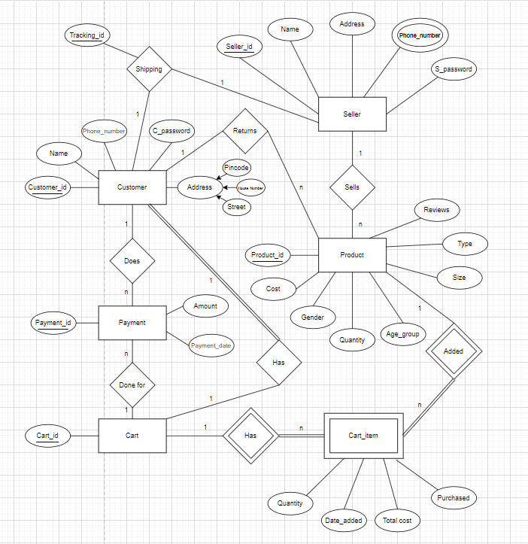

**ER diagram**

**ER to Table**

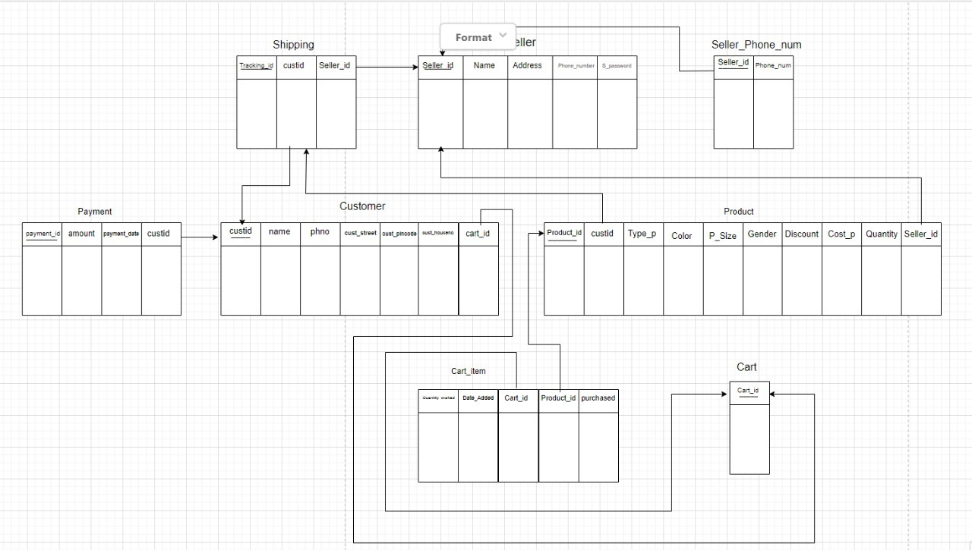

**Normalization**

**1NF:** Since the tables do not contain any composite attribute or multi-valued attributes or their combinations, so they are normalized according to 1NF.

**2NF:** Since there is no non-primary key attribute in the tables that is partially dependent on the primary key, they are normalized according to 2NF.

**3NF:** Since no non-key attribute is transitively dependent on the primary key in the tables, they are normalized according to 3NF.

**BCNF:** Since every determinant is the primary key in the tables, they are normalized according to BCNF.

**4NF:** Since the tables have no multivalued dependencies, so they are normalized according to 4NF

**5NF:** Since the tables don’t have a lossless decomposition into any number of smaller tables (relations), so they are normalized according to 5NF.

**CREATE TABLE COMMANDS:**

CREATE TABLE Seller

(

Seller_id VARCHAR(6) ,

s_pass VARCHAR(10) ,

Name_s VARCHAR(20) ,

Shop_number NUMBER,

Street VARCHAR(30) ,

Pincode NUMBER,

PRIMARY KEY (Seller_id)

);

CREATE TABLE Seller_Phone_num

(

Phone_num NUMBER(10),

Seller_id VARCHAR(6)REFERENCES Seller(Seller_id) ON DELETE CASCADE,

PRIMARY KEY (Phone_num, Seller_id)

);

CREATE TABLE Cart

(

Cart_id VARCHAR(7) NOT NULL,

CONSTRAINT pk_cart PRIMARY KEY(Cart_id)

);

CREATE TABLE customer(  
name VARCHAR(20),

phno NUMBER(10),

custid VARCHAR(12) PRIMARY KEY,

cust_houseno NUMBER(10),

cust_street VARCHAR(40),

cust_pincode NUMBER(10),

cart_id VARCHAR(7) REFERENCES cart(cart_id));

CREATE TABLE SHIPPING

(

Tracking_id VARCHAR (13) PRIMARY KEY,

custid VARCHAR(12) REFERENCES Customer(custid),

Seller_id VARCHAR(6)REFERENCES Seller(Seller_id) ON DELETE SET NULL

);

CREATE TABLE payment(  
payment_id VARCHAR(20) PRIMARY KEY,

amount NUMBER(10),

payment_date DATE,

custid VARCHAR(12) REFERENCES customer(custid));

CREATE TABLE Product

(

Product_id VARCHAR(7) NOT NULL,

custid VARCHAR(12),

Type_p VARCHAR(7) NOT NULL,

Color VARCHAR(15) NOT NULL,

P_Size VARCHAR(2) NOT NULL,

Gender CHAR(1) NOT NULL,

Discount NUMBER(2) NOT NULL,

Cost_p NUMBER(5) NOT NULL,

Quantity NUMBER(2) NOT NULL,

Seller_id VARCHAR(6),

PRIMARY KEY (Product_id),

FOREIGN KEY (Seller_id) REFERENCES Seller(Seller_id) ON DELETE SET NULL,

FOREIGN KEY (custid) REFERENCES customer(custid)

ON DELETE SET NULL

);

CREATE TABLE Cart_item

(

Quantity_wished NUMBER(1) NOT NULL,

Date_Added DATE NOT NULL,

Cart_id VARCHAR(7) NOT NULL,

Product_id VARCHAR(7) NOT NULL,

purchased VARCHAR(5),

CONSTRAINT fk_cart FOREIGN KEY (Cart_id) REFERENCES Cart(Cart_id),

CONSTRAINT fk_product FOREIGN KEY (Product_id) REFERENCES Product(Product_id),

CONSTRAINT pk_cart_item Primary key(Cart_id,Product_id)

);

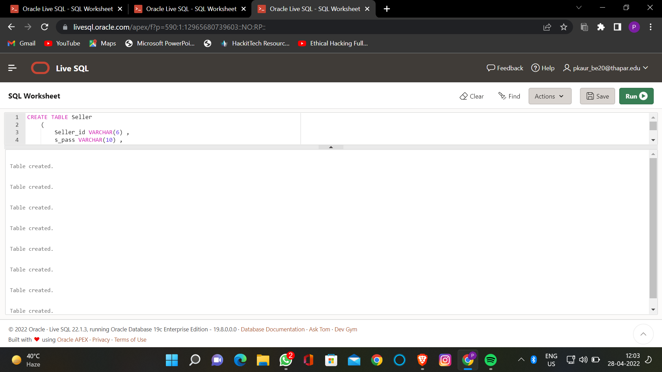

**INSERTION COMMANDS:**

insert into Seller values('1ABQ36','#123','Ajitpal',1470,'Rajamata Street',110003);

insert into Seller values('1CFQ36','#456','Raman',2134,'Ram Laal Chowk',110005);

insert into Seller values('26KL74','#ABCD','Amrit',73,'Munshi Chowk',400004);

insert into Seller values('17KLP7','#R$23','Gopal',677,'Sahibzada Nagar',140307);

insert into Seller values('23EFD5','a345d','Sumita',523,'Nawa kot Nagar',132103);

insert into Seller_Phone_num values(9873654321,'26KL74');

insert into Seller_Phone_num values(9813732561,'23EFD5');

insert into Seller_Phone_num values(9765310987,'26KL74');

insert into Seller_Phone_num values(9349845100,'1ABQ36');

insert into Seller_Phone_num values(8453877652,'26KL74');

insert into Seller_Phone_num values(8873654321,'1CFQ36');

insert into Seller_Phone_num values(7765654321,'17KLP7');

insert into Cart values('1ADF34');

insert into Cart values('2FDF54');

insert into Cart values('1QRT89');

insert into Cart values('5MPL24');

insert into Cart values('1HDF98');

insert into customer values('Mansi',8862473245,'765FTYGUHUHB',1432,'Gandhi Nagar Street',147001,'2FDF54');

insert into customer values('Ajay',9834567754,'765DBHBABDBB',234,'Sabzi Mandi Street',110864,'1ADF34');

insert into customer values('Jitender',9865467356,'565FTYHYHUHB',75,'Ranjit Nagar',110086,'1QRT89');

insert into customer values('Dhruv',7865473240,'765FTYGUHUUI',101,'Virat Nagar',147345,'5MPL24');

insert into customer values('Arsh',9855327255,'865FTYGRHIHB',3465,'Model Town',132103,'1HDF98');

insert into SHIPPING values('7YIUGF','765FTYGUHUHB','26KL74');

insert into SHIPPING values('87HHKL','765DBHBABDBB','1ABQ36');

insert into SHIPPING values('34VHJF','565FTYHYHUHB','23EFD5');

insert into SHIPPING values('45GVCW','765FTYGUHUUI','1CFQ36');

insert into SHIPPING values('87JFKJ','865FTYGRHIHB','17KLP7');

insert into payment values('TEJBKD524VVR',5000,'23-DEC-2022','765FTYGUHUHB');

insert into payment values('TYRFWD524VVR',500,'25-DEC-2021','765DBHBABDBB');

insert into payment values('YSJBKD524VVR',2730,'12-SEP-2020','565FTYHYHUHB');

insert into payment values('RFGBKD524VVR',420,'02-AUG-2018','765FTYGUHUUI');

insert into payment values('TEYPOC524VVR',1190,'06-JUN-2019','865FTYGRHIHB');

insert into payment values('TEJBKD545VVR',750,'25-OCT-2015','565FTYHYHUHB');

insert into Productvalues('1267543','765FTYGUHUHB','Sandal','Blue','6','F',20,420,1,'26KL74');

insert into Product values('2345676','765DBHBABDBB','Coat','Black','32','M',30,2730,1,'23EFD5');

insert into Product values('3647833','565FTYHYHUHB','Shoes','Green','9','M',25,5000,2,'1ABQ36');

insert into Product values('7384903','765FTYGUHUUI','Shirt','White','12','F',50,500,1,'1CFQ36');

insert into Product values('4567839','865FTYGRHIHB','Jeans','Blue','36','F',0,1190,1,'17KLP7');

insert into Cart_item values(1,'03-JUN-2022','1ADF34','1267543','yes');

insert into Cart_item values(1,'23-AUG-2021','2FDF54','2345676','no');

insert into Cart_item values(1,'06-JAN-2020','1QRT89','3647833','yes');

insert into Cart_item values(1,'27-MAY-2022','5MPL24','7384903','no');

insert into Cart_item values(1,'15-DEC-2021','1HDF98','4567839','yes');

insert into Cart_item values(1,'17-DEC-2021','1HDF98','2345676','no');

**QUERIES:**

1. **Alter name_s as Firstname, length of firstname as 15 and add one more field of Last_name**

Alter table Seller

rename column Name_s to FirstName ;

Alter table Seller

modify FirstName varchar(15);

Alter table Seller

add LastName varchar(15);

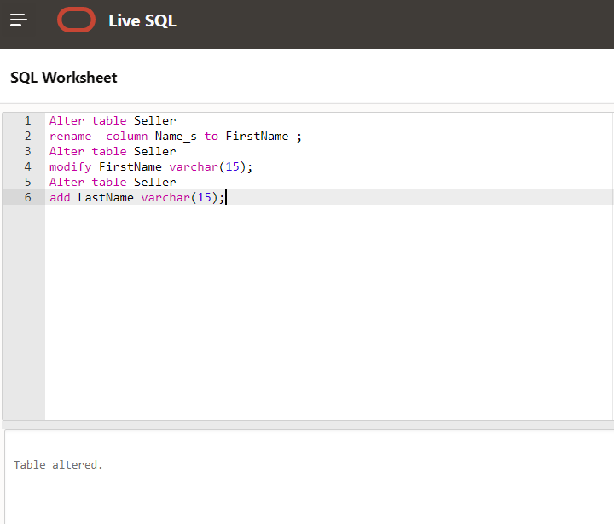

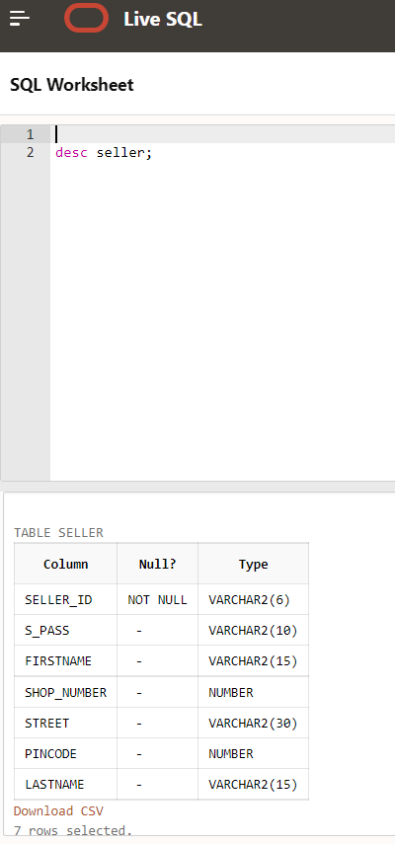

1. **If a seller wants update his phone number**

update Seller_Phone_num set Phone_num=9765310988 where

seller_id='26KL74' and Phone_num=9765310987;

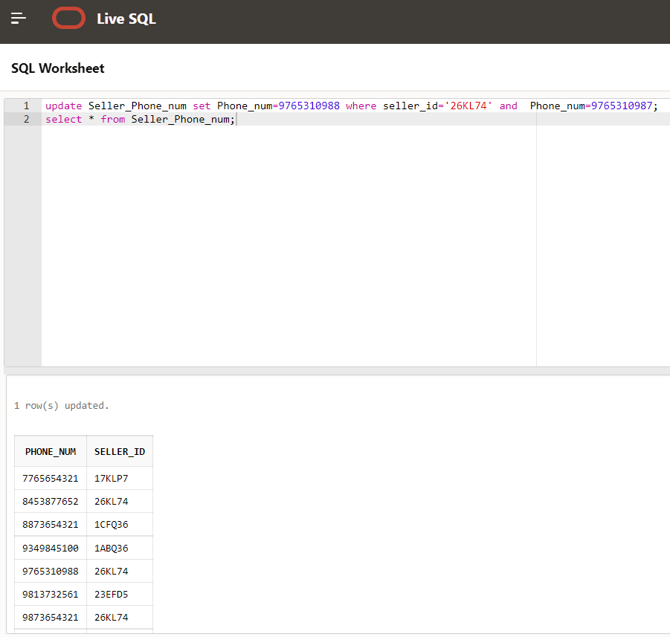

1. **If the customer wants to see details of the product present in the cart**

select * from product where product_id in(

select product_id from Cart_item where purchased=’no’ and Cart_id in(

Select Cart_id from Customer where custid=’765FTYGUHUHB’

));

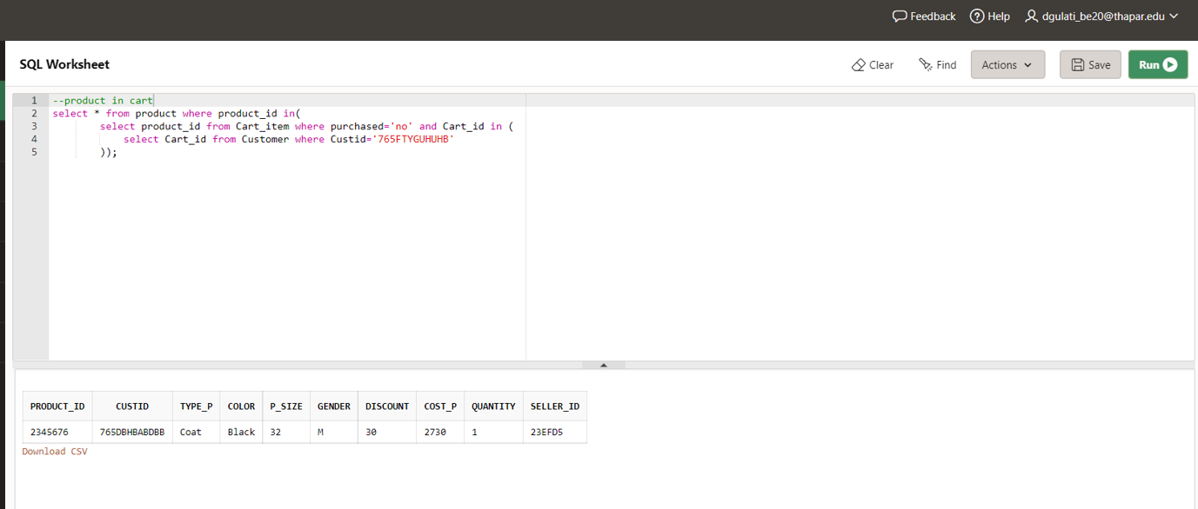

1. **If a customer wants to see order history**

select product_id,Quantity_wished from Cart_item where purchased='yes' and Cart_id in (select Cart_id from customer where Custid='765DBHBABDBB');

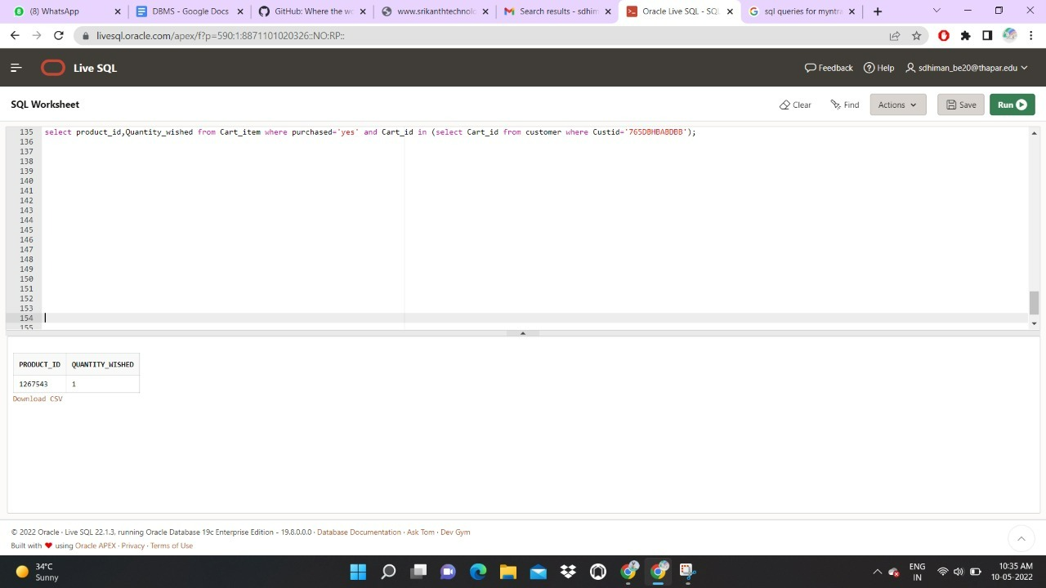

1. **Customer wants to see filtered products on the basis of size,gender,type**

select product_id, Color, Cost_p, Seller_id from product where Type_p='jeans' and P_size='36' and Gender='F' and Quantity>0);

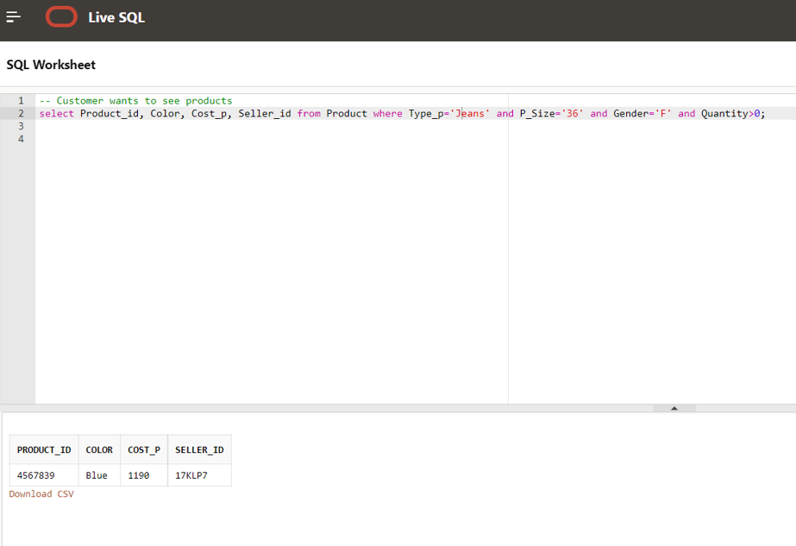

1. **If customer wants to modify the cart**

Select * from Cart_item;

delete from cart_item where purchased=’no’and product_id='2345676' and Cart_id in (select cart_id from Customer where Custid='865FTYGRHIHB'

Select * from Cart_item

);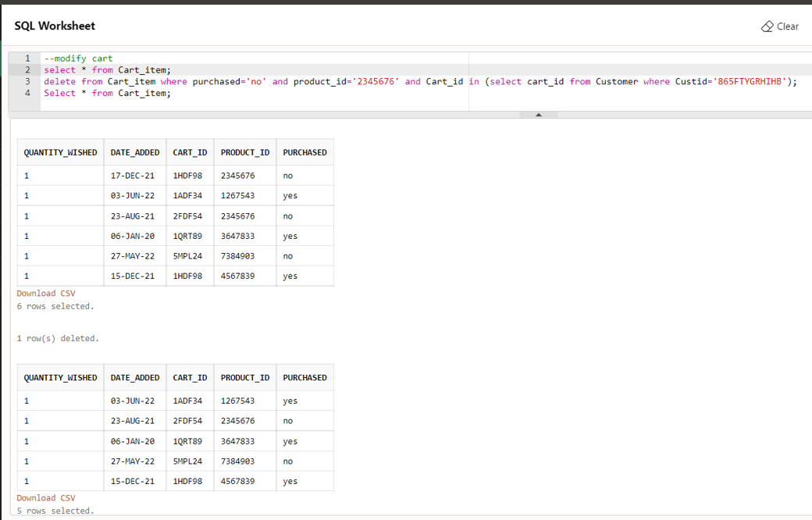

1. **If a seller stops selling his product**

delete from seller where seller_id = '26KL74';

update product set quantity = 00 where seller_id is NULL;

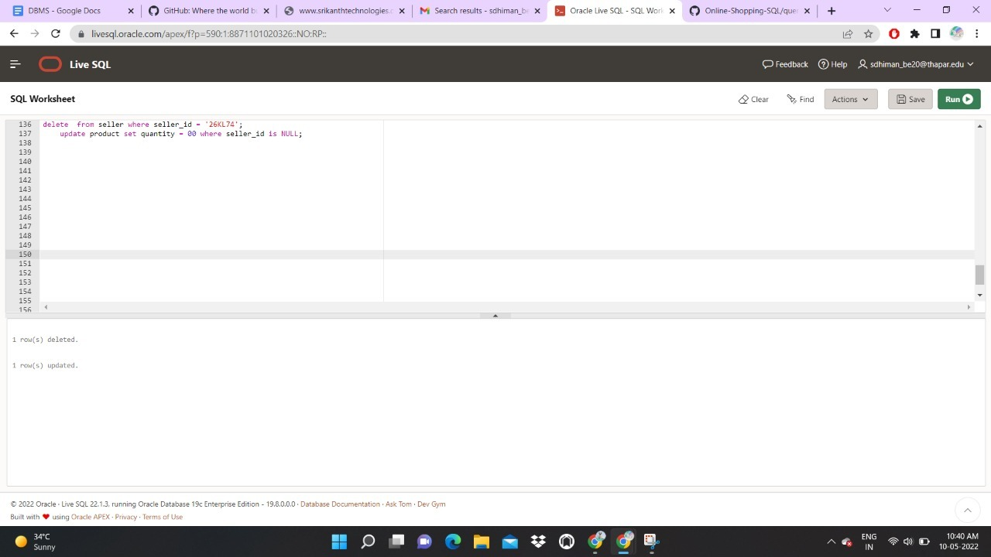

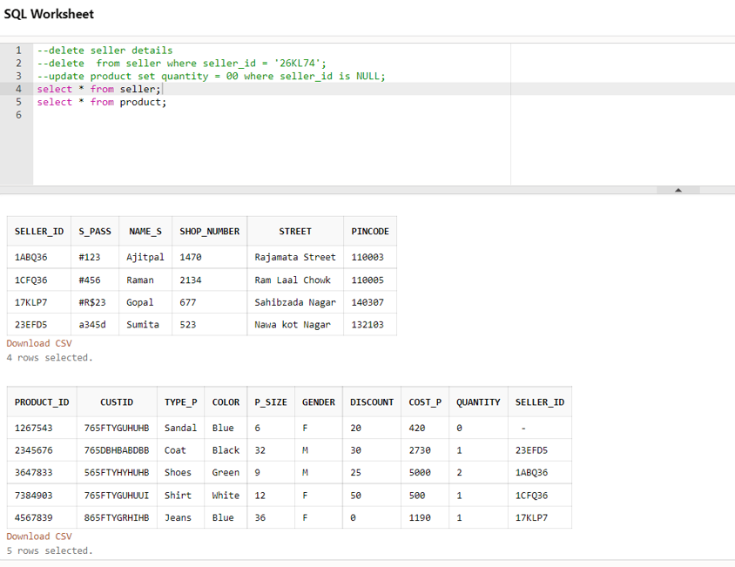

1. **If the admin wants to see what are the product purchased on the particular date**

select product_id from cart_item where (purchased='yes' and date_added='15-DEC-2021');

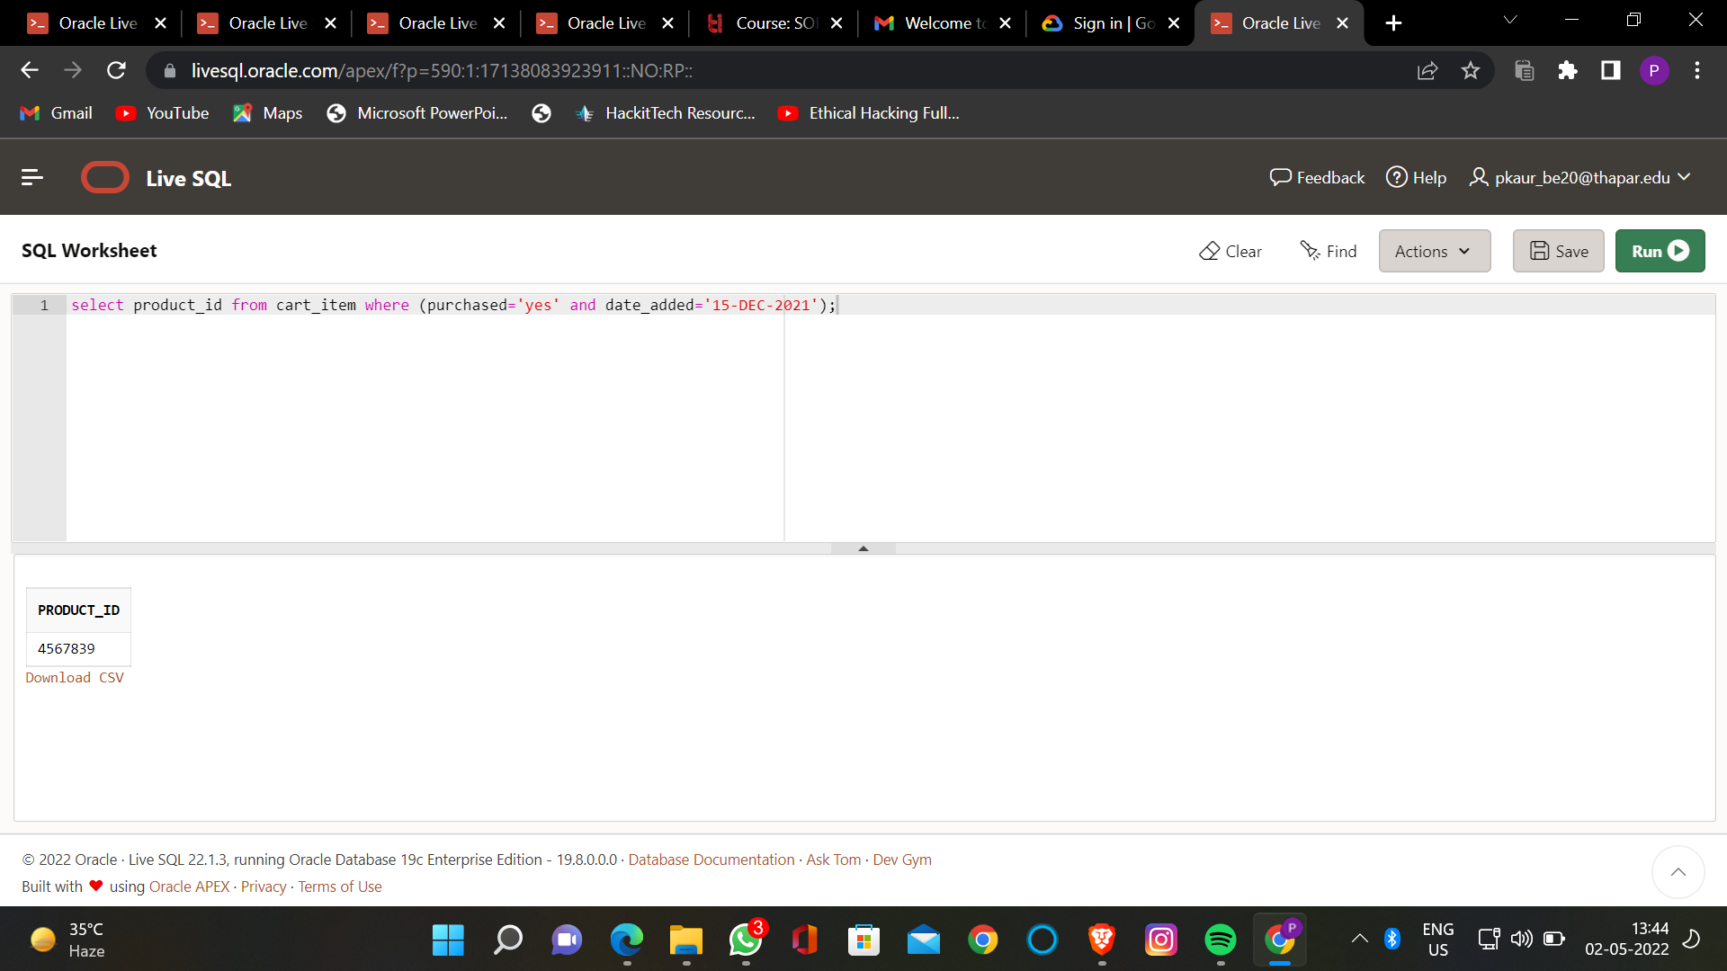

1. **How much product sold on the particular date**

select count(product_id) count_pid,date_added from Cart_item WHERE purchased='yes' group by(Date_Added) ;

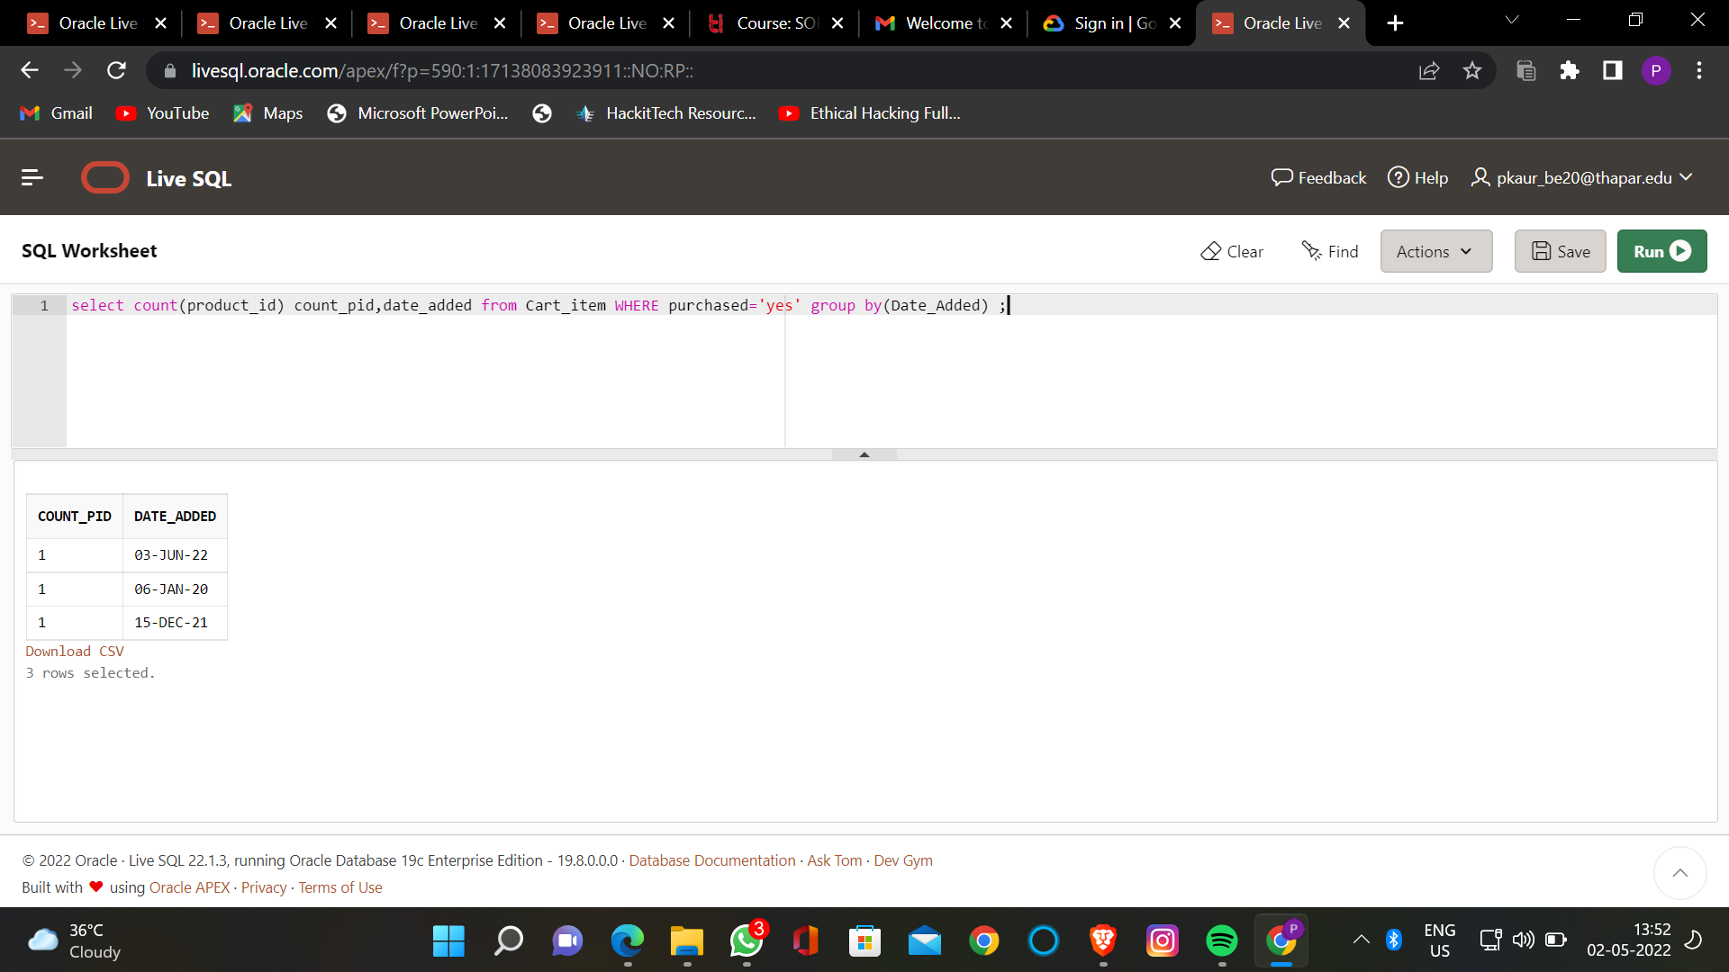

1. **If a customer want to know the total price present in the cart**

select sum(quantity_wished * cost_p) total_payable from product p join cart_item c on p.product_id=c.product_id

where purchased = 'no' and c.product_id in (select product_id from cart_item where cart_id in(select Cart_id from customer where custid='765FTYGUHUUI'));

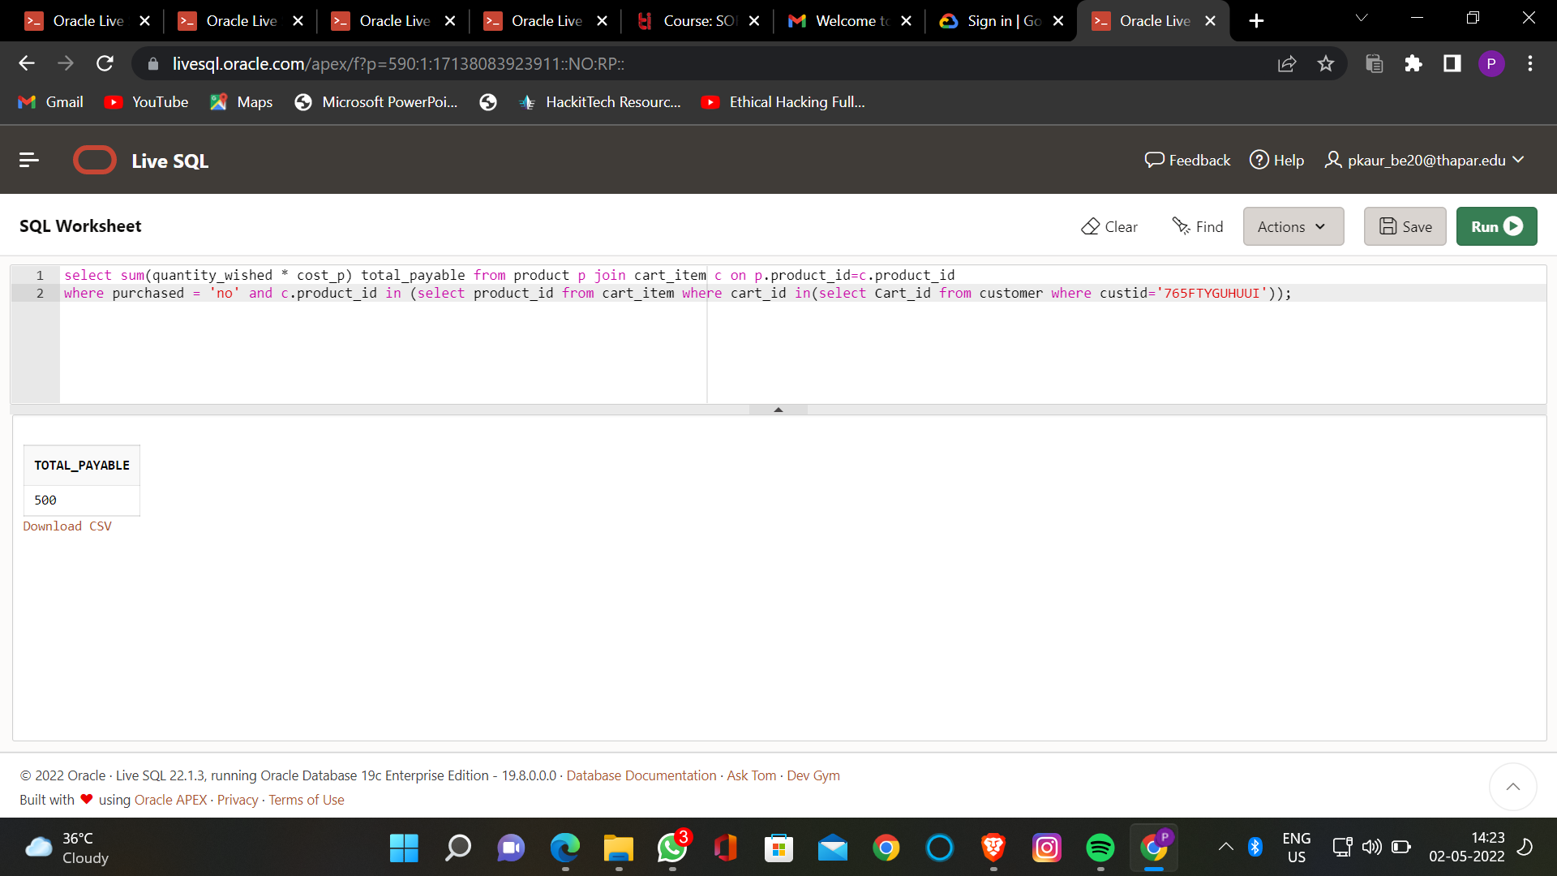

1. **Show the details of the customer who has not purchased any thing**

Select * from customer where custid not in (select custid from Payment);

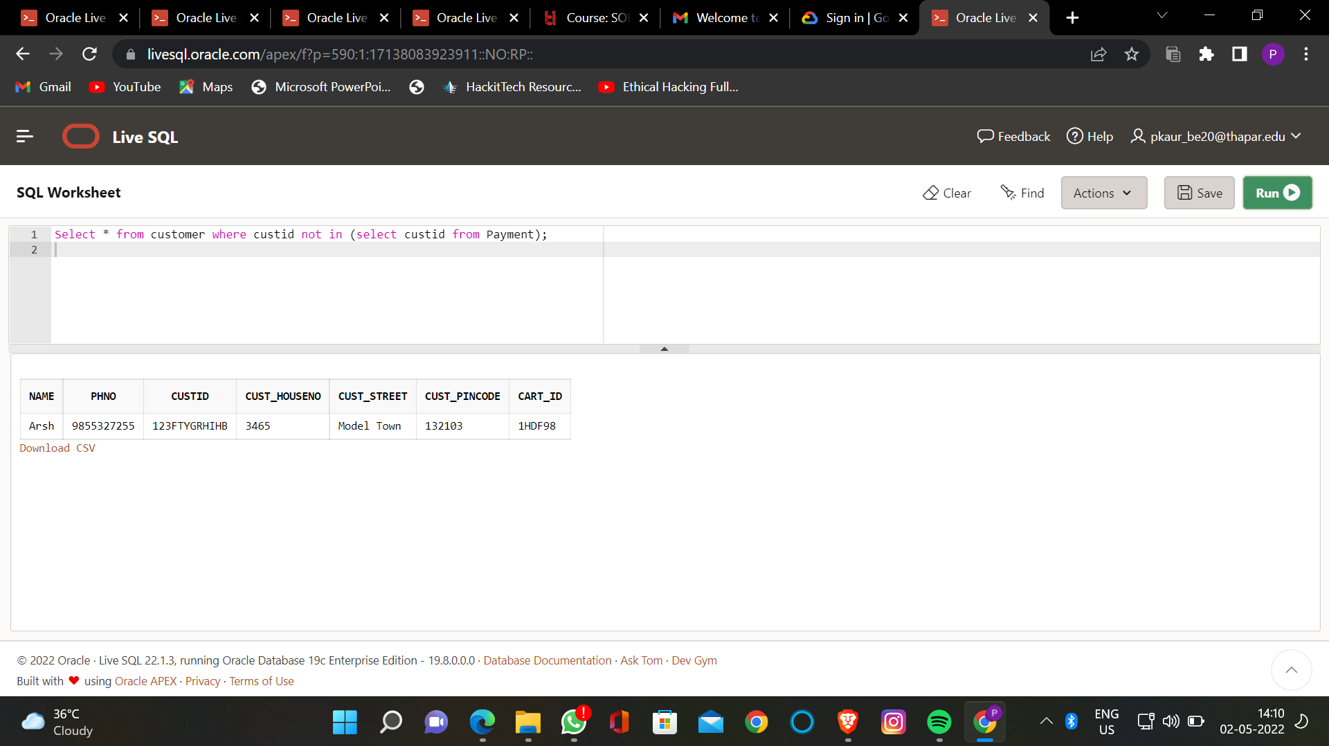

1. **Find total sales of a seller..**

select sum(quantity_wished * cost_p ) total_profit,seller_id from product p join cart_item c on p.product_id=c.product_id WHERE purchased='yes' group by seller_id;

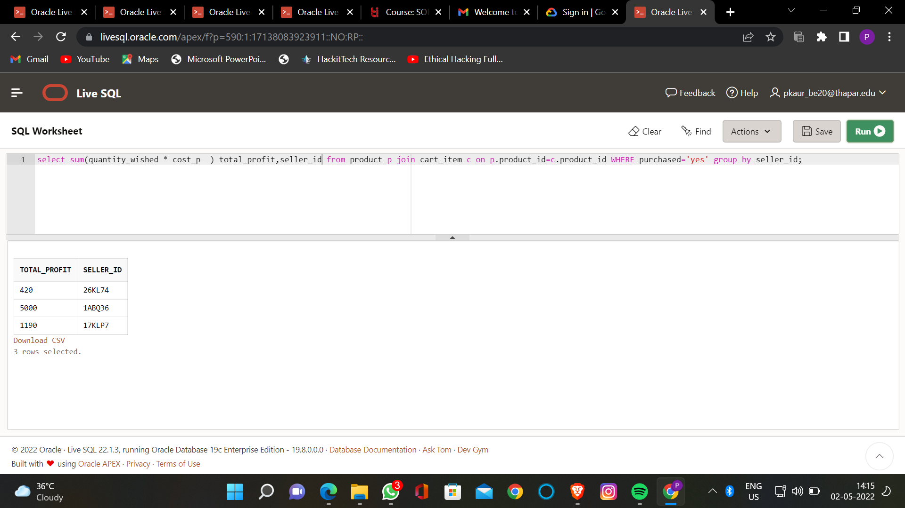

1. **Revenue generated by each seller on the particular date**

select name_s, seller_id, revenue from seller,

(select seller_id as s_id, sum(Cost_p*Quantity) as revenue from product group by seller_id)

where seller.seller_id = s_id

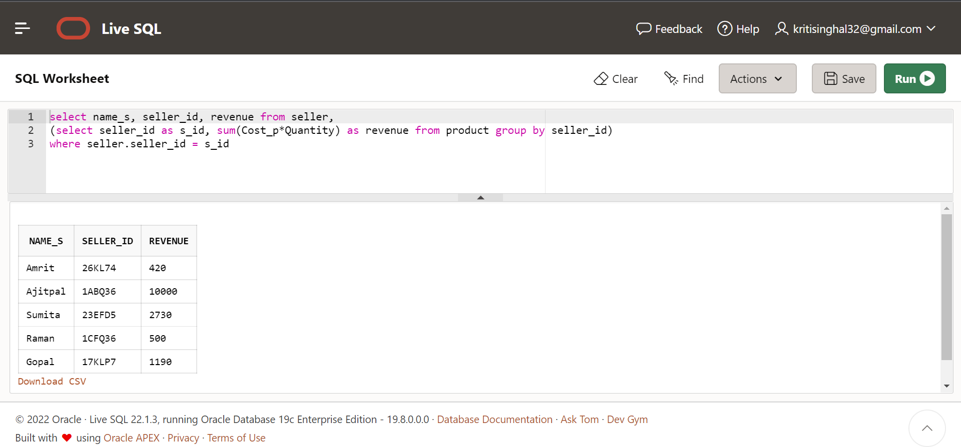

1. **Create a view to display the payment details for a particular date**

CREATE VIEW payment_details AS

SELECT payment_id, amount

FROM payment

WHERE payment_date = '23-DEC-2022';

select * from payment_details

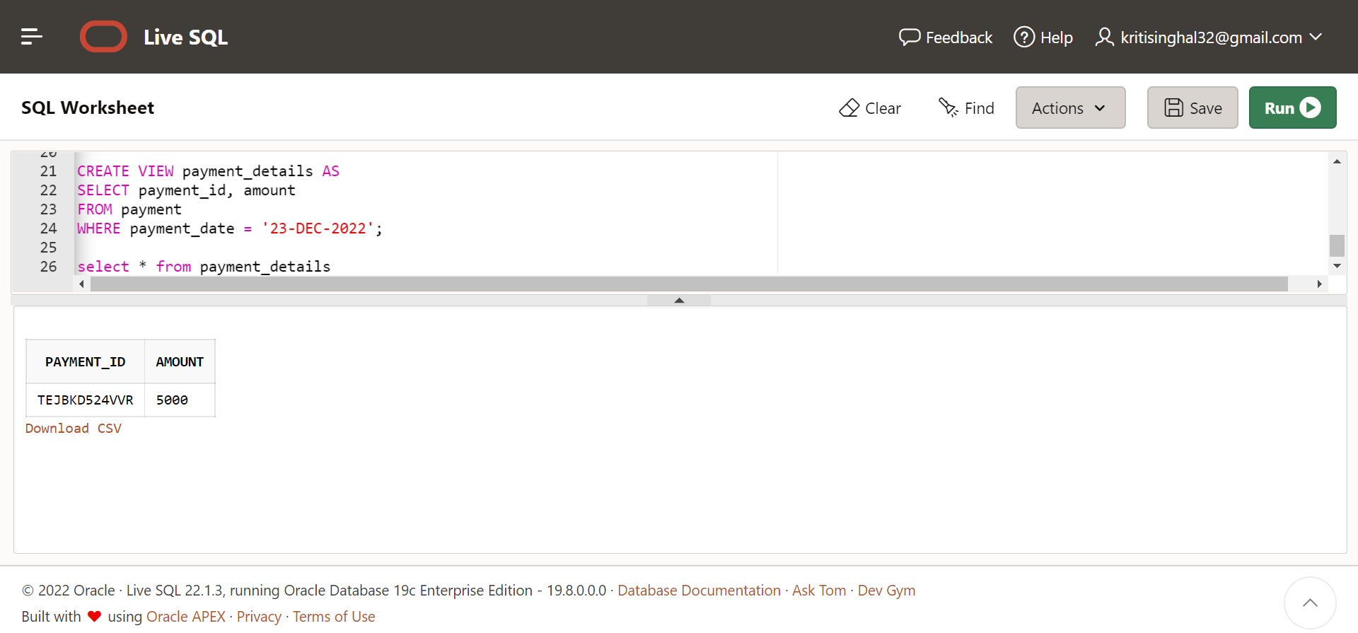

1. **Display the total purchase by each customer**

select name, custid, cost from customer,

(select custid as c_id, sum(Cost_p*Quantity) as cost from product group by custid)

where customer.custid = c_id

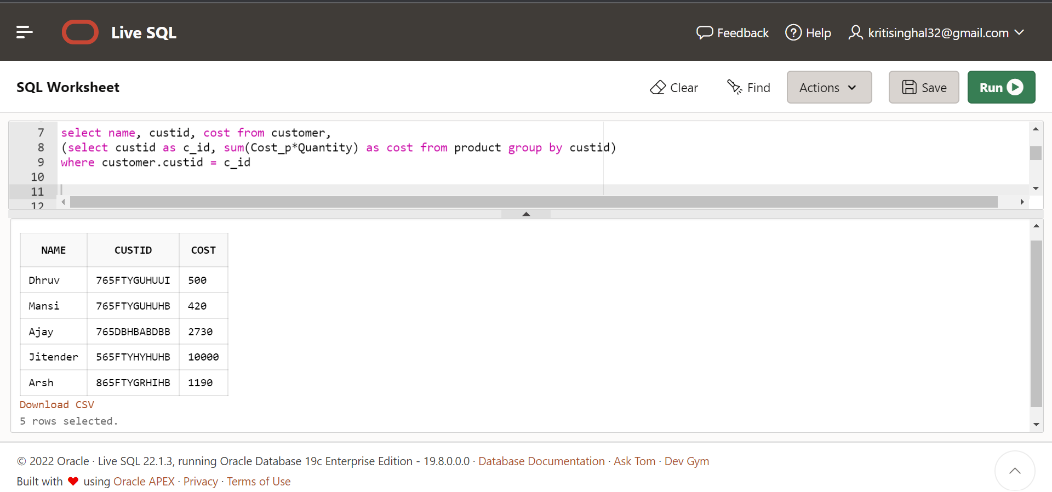

1. **Create a view to display the payment details for today**

CREATE VIEW payment_details_today AS

SELECT payment_id, amount

FROM payment

WHERE payment_date = sysdate;

select * from payment_details_today

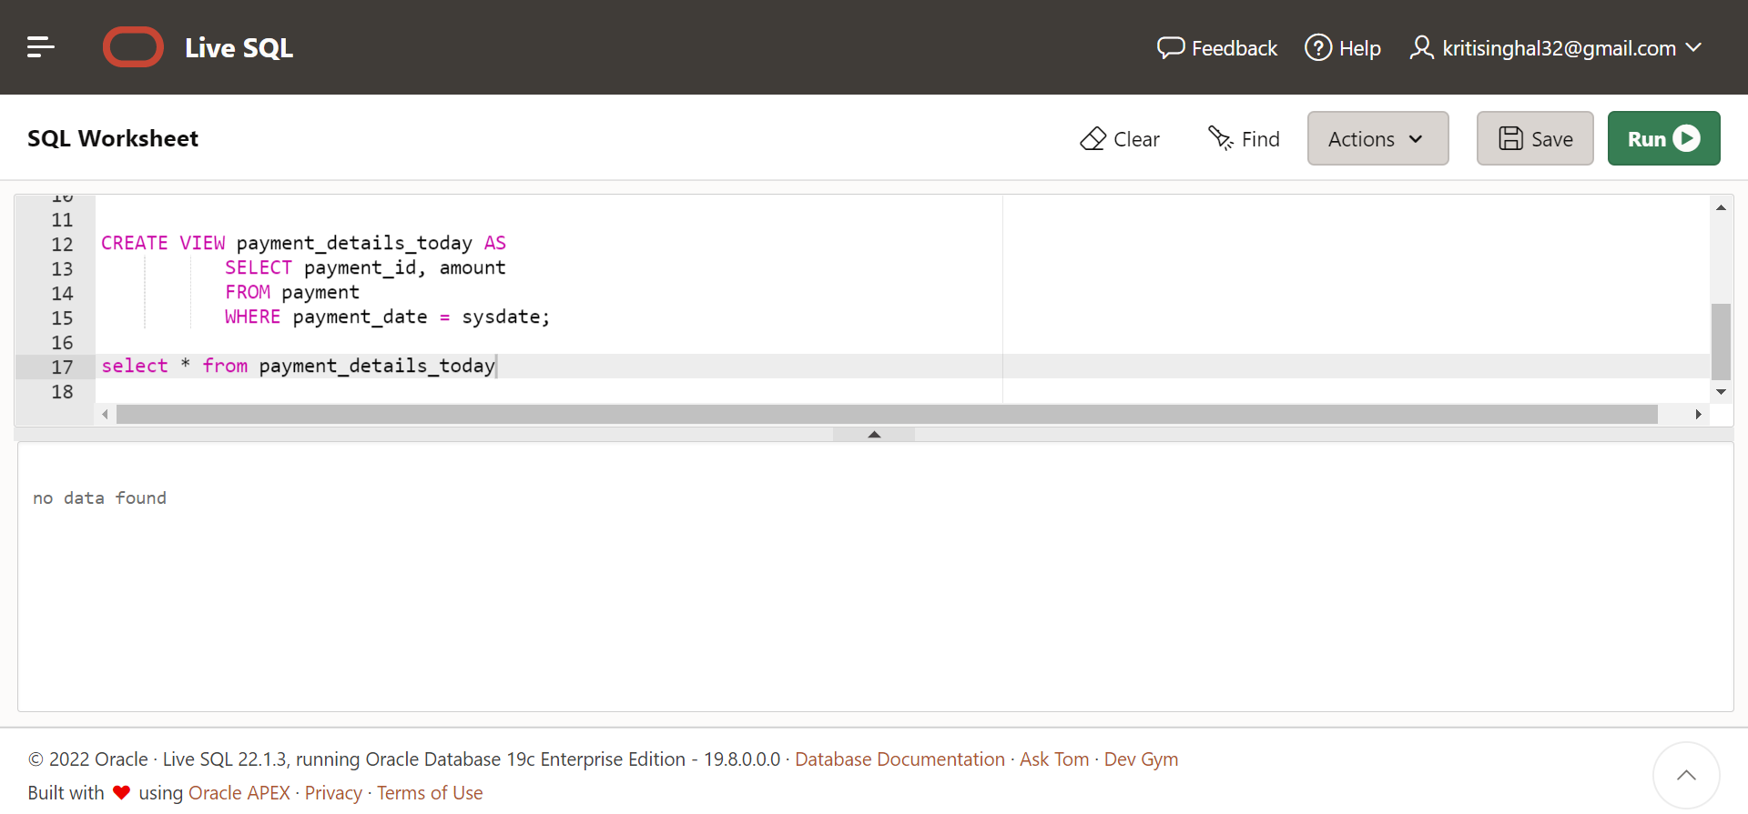

1. **Displaying all contact details for each seller**

SELECT Seller.NAME_S,Seller_Phone_num.PHONE_NUM

FROM Seller , Seller_Phone_num

WHERE Seller.SELLER_ID = Seller_Phone_num.SELLER_ID;

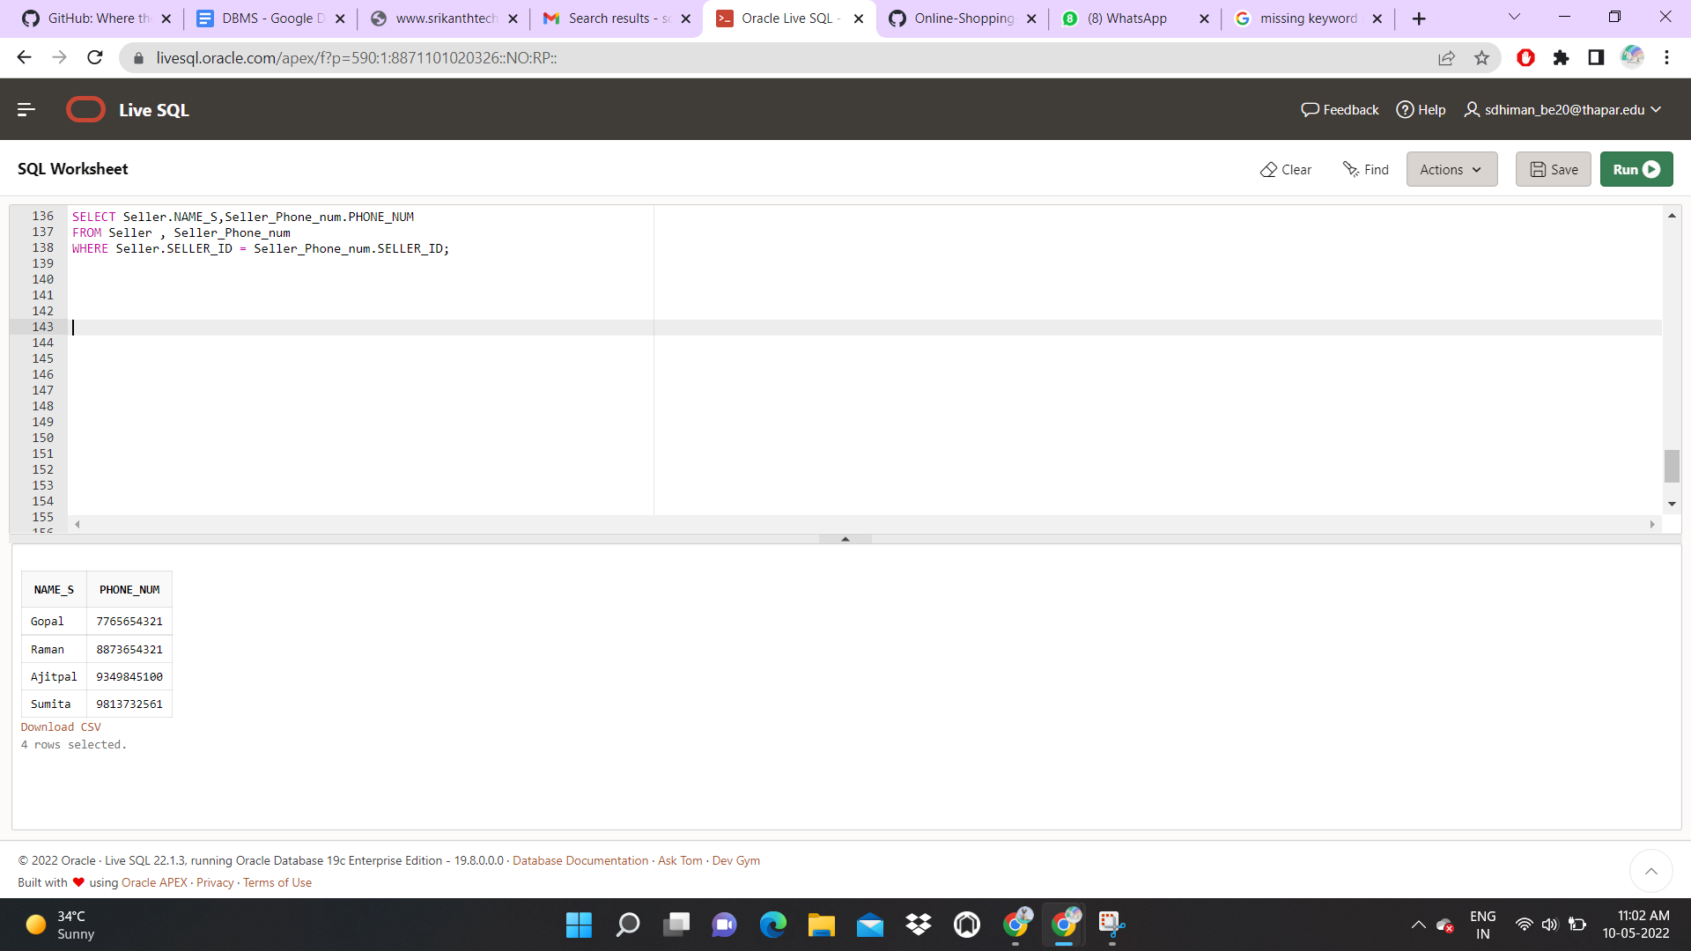

1. **Display details of seller and products sold by him**

select * from seller,product where seller.Seller_id=Product.Seller_id;

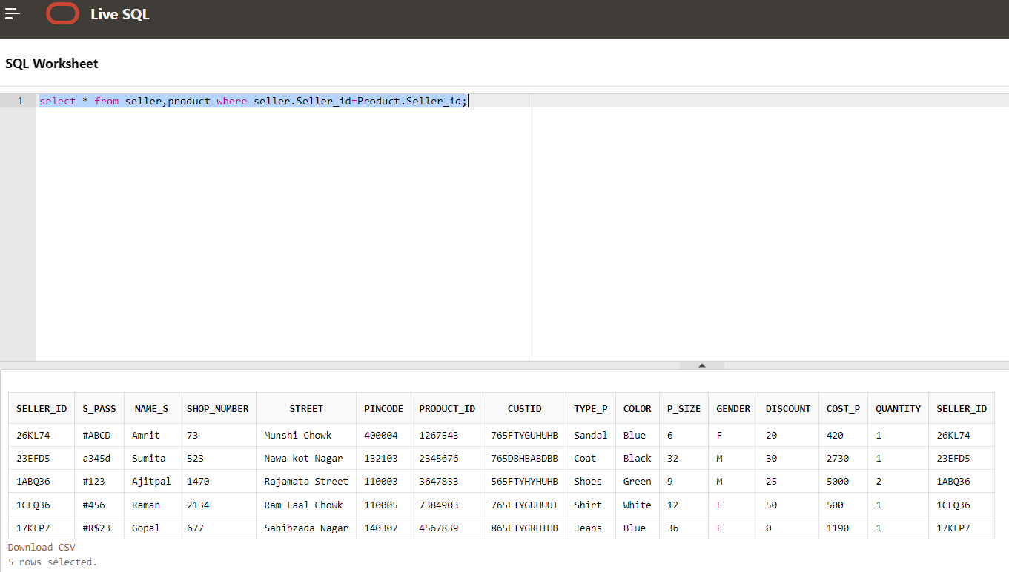

1. **Select ids of seller and customer who belong to same place**

select seller_id,custid from Seller,customer where seller.pincode=customer.cust_pincode;

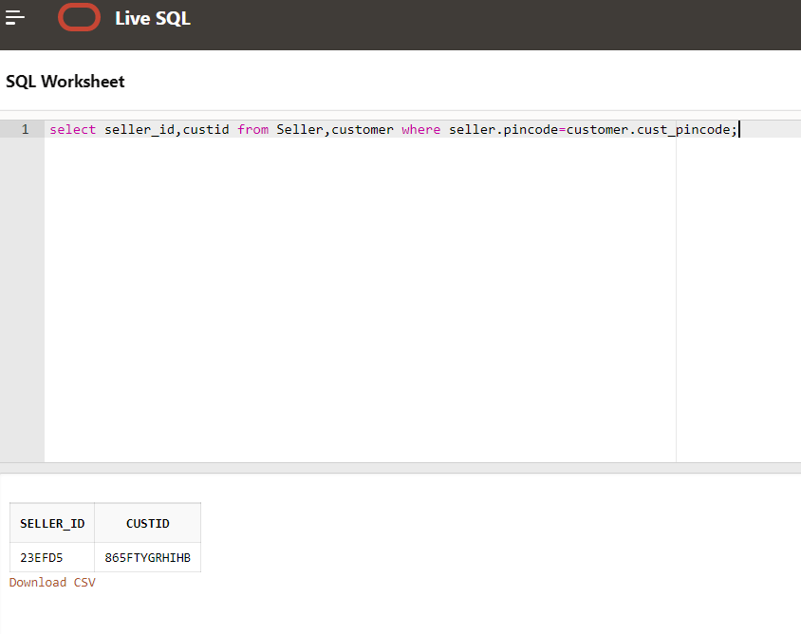

**PL/SQL:**

1. **Displaying a detailed view of each product of a particular product**

Declare

product_details Product%rowtype;

Begin

select * into product_details from product where Product_id = '1267543';

dbms_output.put_line('This is a '|| product_details.Type_p|| ', the color is '|| product_details.Color || ', the size is ' || product_details.P_Size || '. Each product costs '|| product_details.Cost_p || 'INR and the available quantity is '|| product_details.Quantity);

END;

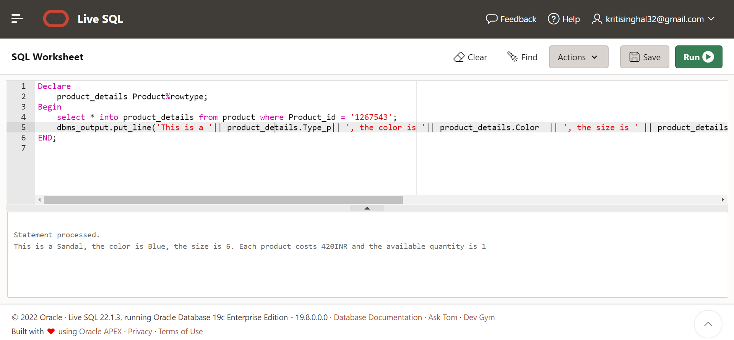

1. **Error Messages displayed when too many rows or no data is selected (Inbuilt Exception Handling)**

DECLARE

product_size VARCHAR(2);

BEGIN

select P_Size from product into product_size where Type_p = 'Shoes';

EXCEPTION

WHEN TOO_MANY_ROWS THEN

DBMS_OUTPUT.PUT_LINE('TOO MANY ROWS');

WHEN NO_DATA_FOUND THEN

DBMS_OUTPUT.PUT_LINE('NO DATA FOUND');

END;

DECLARE

product_size VARCHAR(2);

BEGIN

select P_Size into product_size from product where Type_p = 'Pant';

EXCEPTION

WHEN TOO_MANY_ROWS THEN

DBMS_OUTPUT.PUT_LINE('TOO MANY ROWS');

WHEN NO_DATA_FOUND THEN

DBMS_OUTPUT.PUT_LINE('NO DATA FOUND');

END;

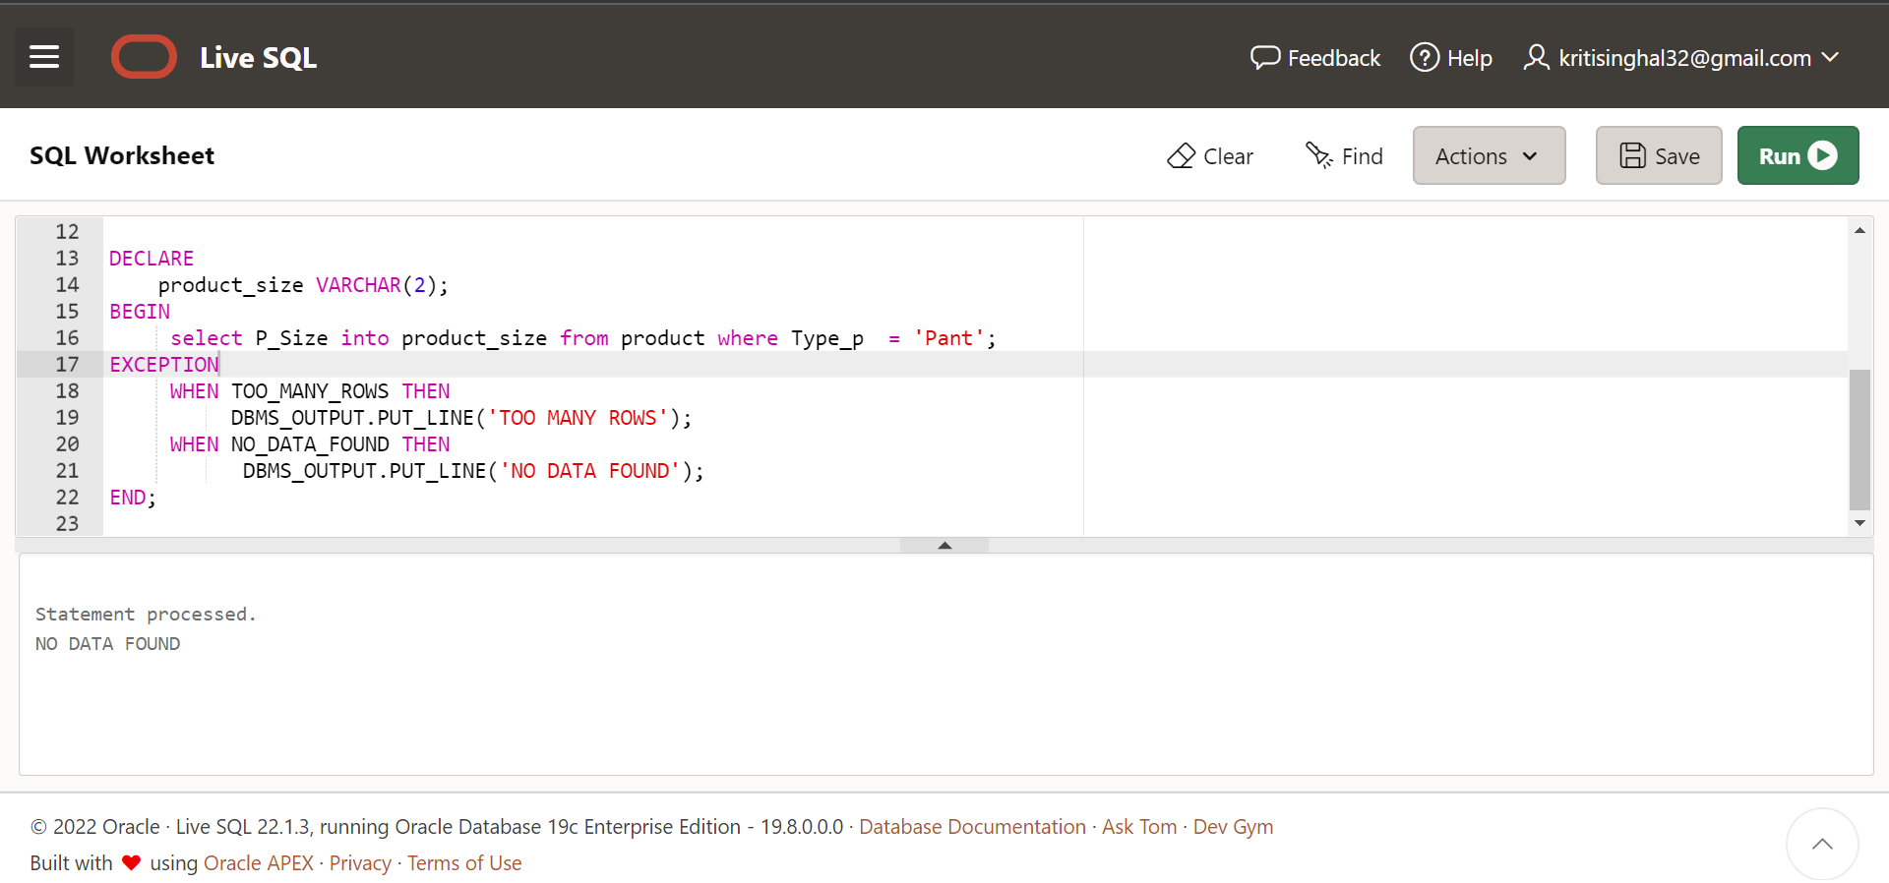

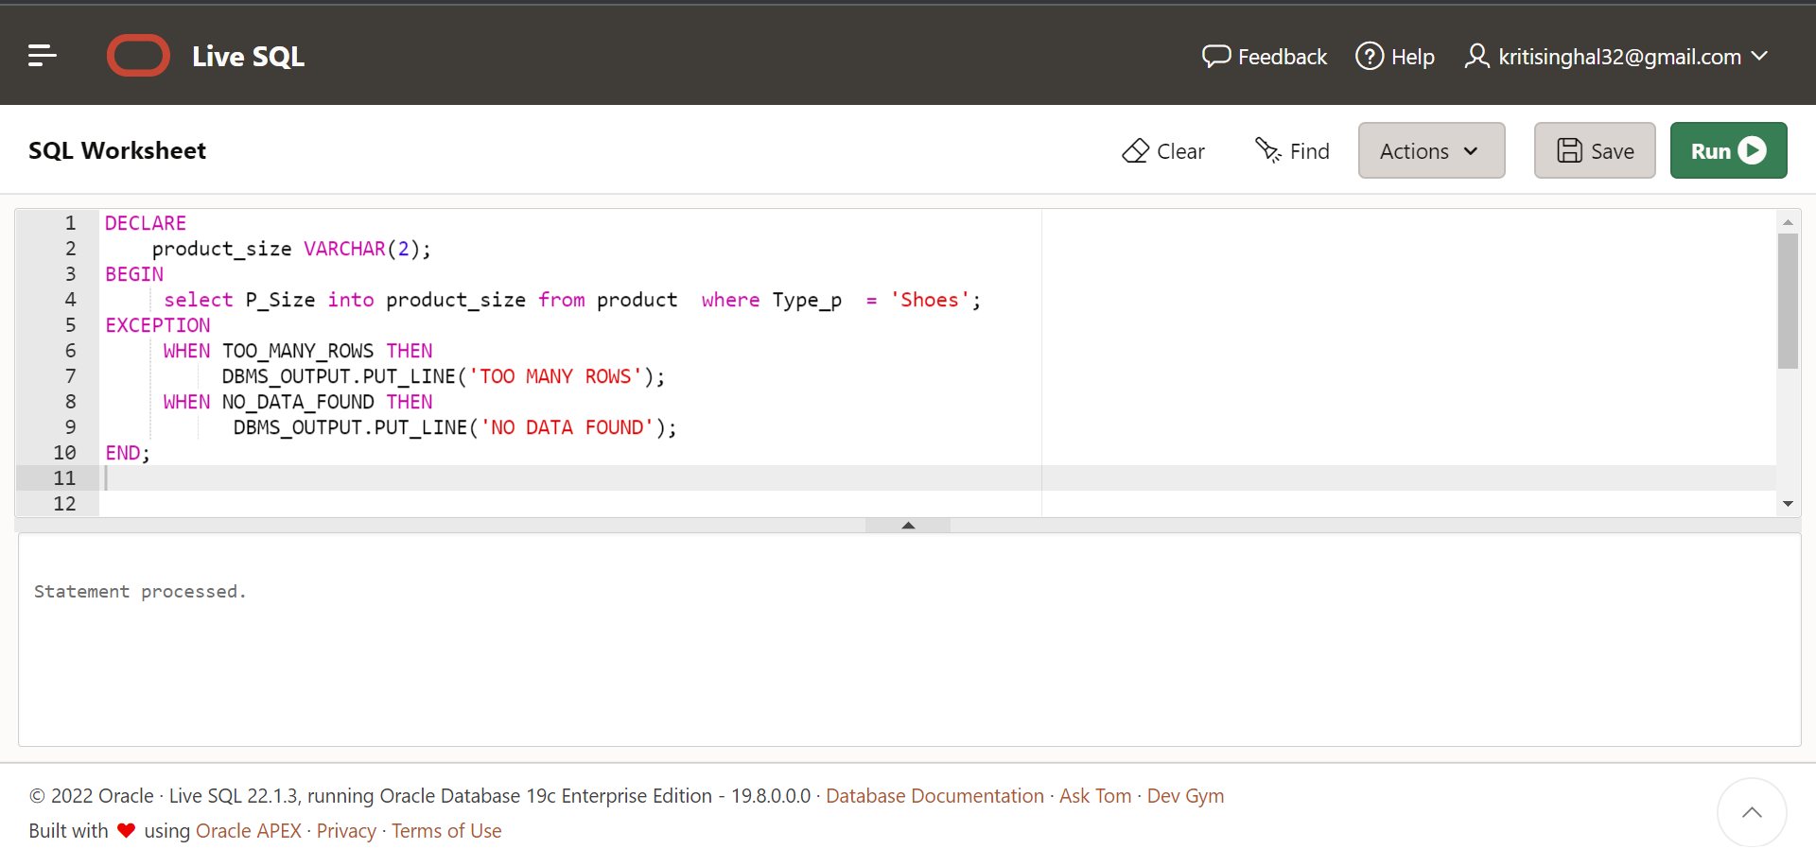

1. **Error Messages displayed when a wrong product id with too many characters is inserted (Non- predefined Exception Handling)**

DECLARE

Incorrect_id EXCEPTION;

PRAGMA EXCEPTION_INIT(Incorrect_id ,-12899);

BEGIN

insert into Product values('126733599','765FTYGUHULL','Pant','Red','38','M',30,120,3,'26KK74');

EXCEPTION

WHEN Incorrect_id THEN

DBMS_OUTPUT.PUT_LINE('Please enter a valid Product ID!');

END;

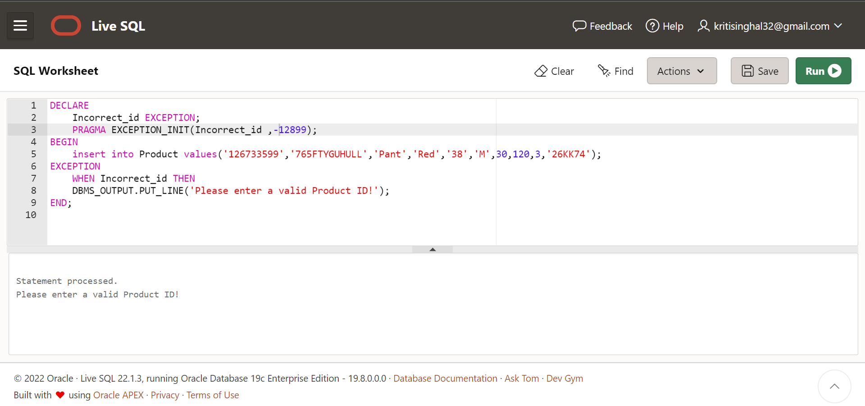

1. **Display all the products that are available in the shop**

DECLARE

cs product.Cost_p%type;

ty product.Type_p%type;

id product.product_id%type;

cursor cf is

select product_id,Cost_p,Type_p from product;

BEGIN

open cf;

loop

fetch cf into id,cs,ty;

exit when cf%notfound;

dbms_output.put_line('Product' || id || 'has cost ' || cs || ' and the type is ' || ty);

end loop;

close cf;

EXCEPTION

when no_data_found then

dbms_output.put_line('No products available');

END;

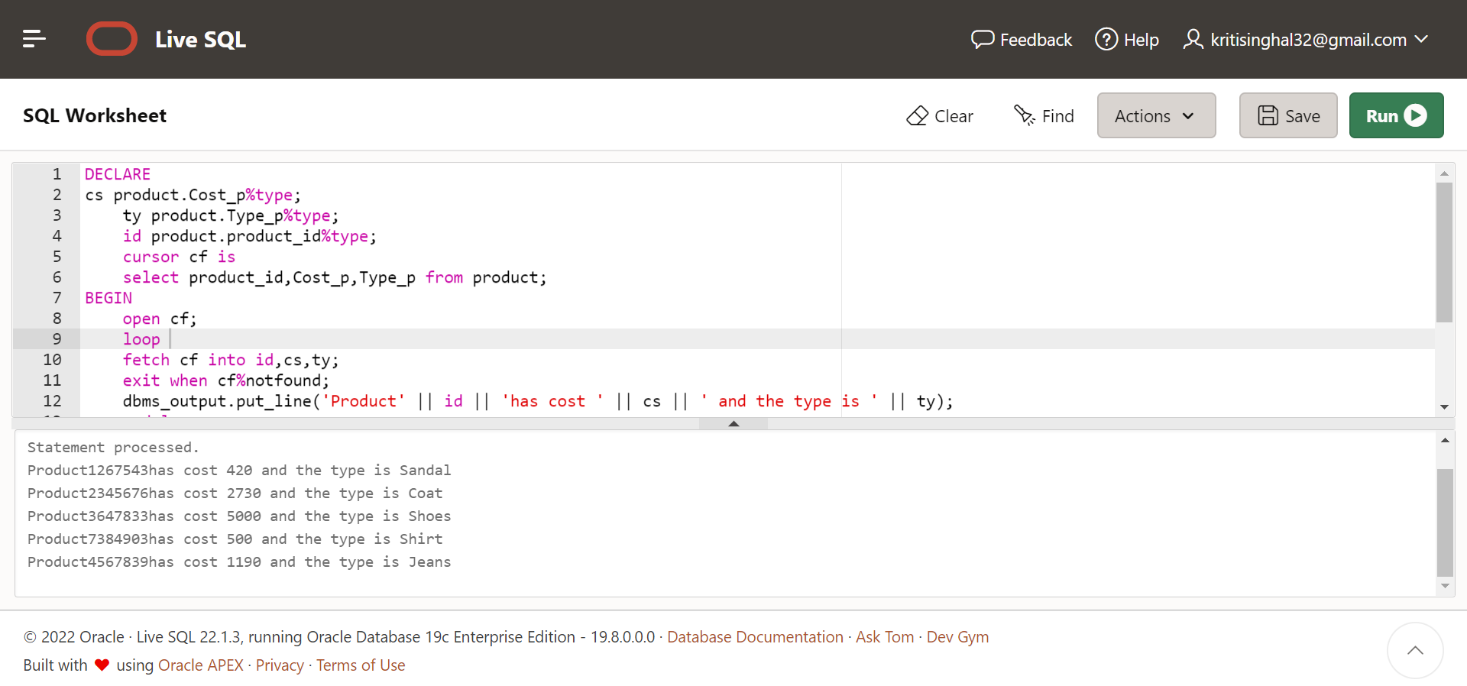

1. **Raise error if product being ordered has a quantity of 0 (User defined Exception Handling)**

Declare

product_details Product%rowtype;

out_of_stock exception;

Begin

select * into product_details from product where Product_id = '1267543';

if product_details.Quantity <= 0 THEN

RAISE out_of_stock;

end if;

dbms_output.put_line( product_details.Type_p|| ' is available quantity is '|| product_details.Quantity);

Exception

When out_of_stock THEN

dbms_output.put_line('Order more items');

END;

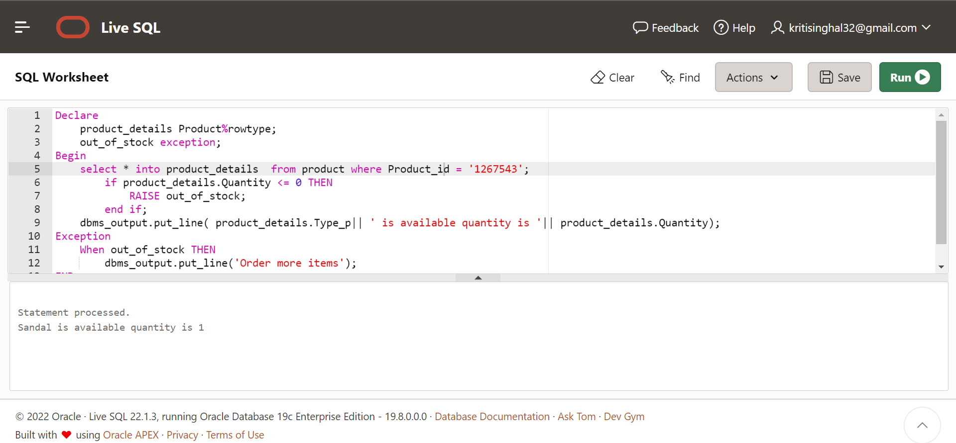

1. **Cursor for loop for finding details of a seller with given seller id**

declare

cursor c(s varchar) is

select * from seller where Seller_id=s;

begin

for rec in c('17KLP7') loop

dbms_output.put_line( 'password= '||rec.s_pass||' name= '||rec.Name_s||' shopnumber= '||rec.Shop_number||' street= '||rec.Street||' pincode= '||rec.Pincode);

end loop;

End;

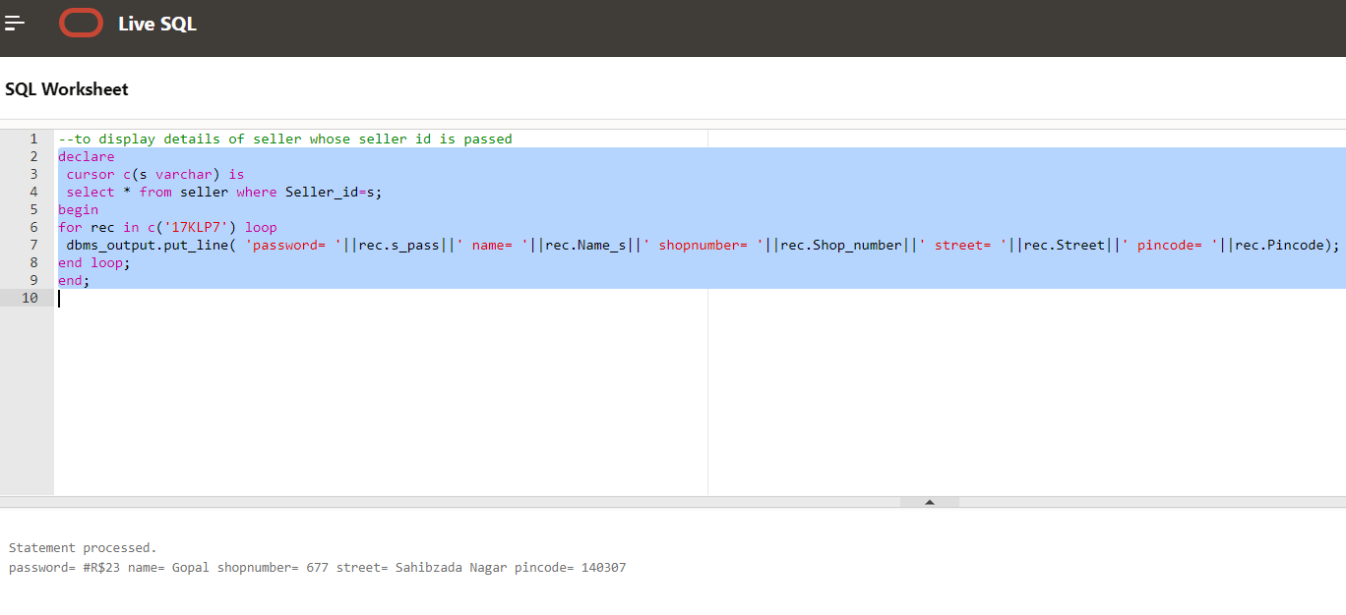

1. **Apply 10% discount on all items using cursor**

declare

cursor c is select * from Product;

d number

p number;

begin

for rec in c loop

p:=rec.cost_p-0.1*rec.cost_p;

d:=rec.Discount+10;

update Product set cost_p=p,Discount=d where Product_id=rec.Product_id;

end loop;

end;

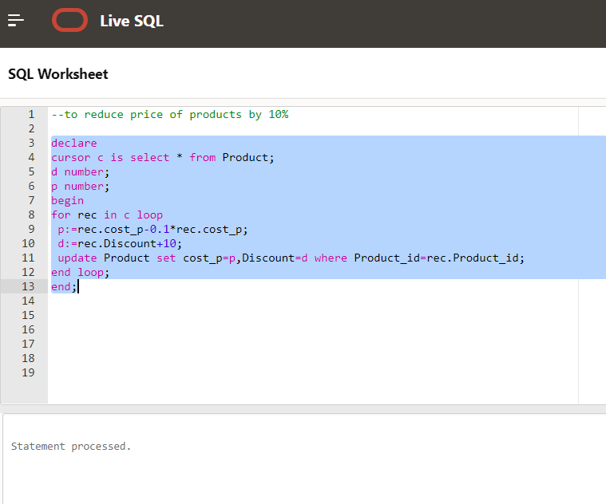

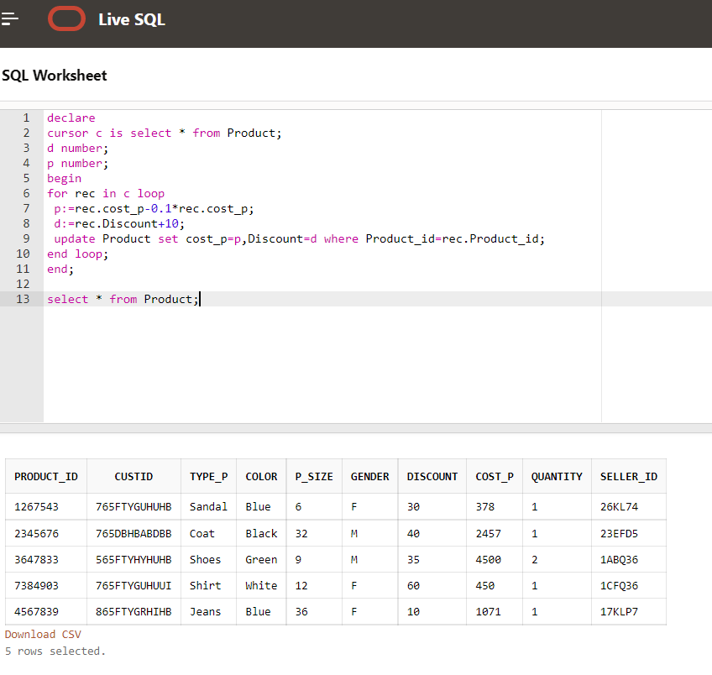

1. **Procedure which returns the type of product with the cost less than the given cost**

create or replace procedure cost_filter(c in number,t in varchar)

is

cs product.Cost_p%type;

ty product.Type_p%type;

id product.product_id%type;

cursor cf is

select product_id,Cost_p,Type_p from product where Cost_p<c and Type_p=t;

begin

open cf;

loop

fetch cf into id,cs,ty;

exit when cf%notfound;

dbms_output.put_line('Product' || id || 'has cost ' || cs || ' and the type is' || ty);

end loop;

close cf;

exception

when no_data_found then

dbms_output.put_line('Sorry no such products exist');

end;

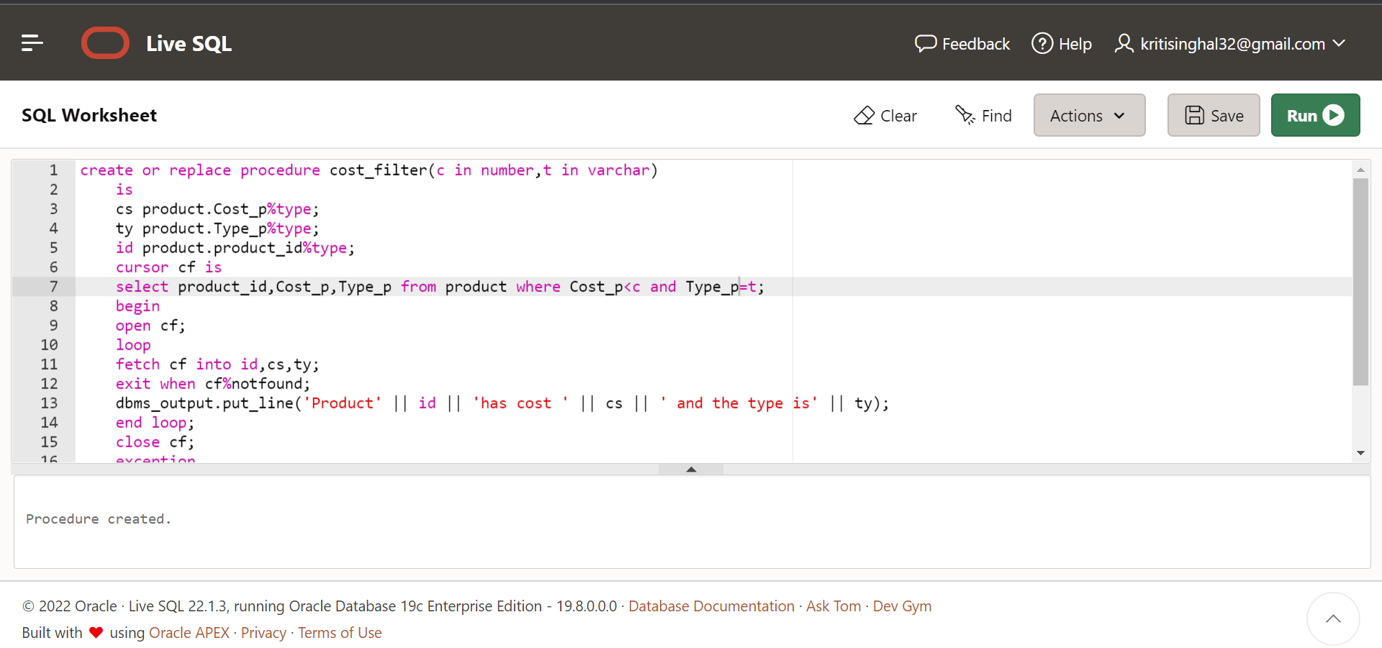

1. **Function which returns total number of products which a particular seller sells**

create or replace function totalProducts(sId in varchar)

return number

is

total number(2):=0;

begin

select count(*) into total

from product

where seller_id=sId;

return total;

end;

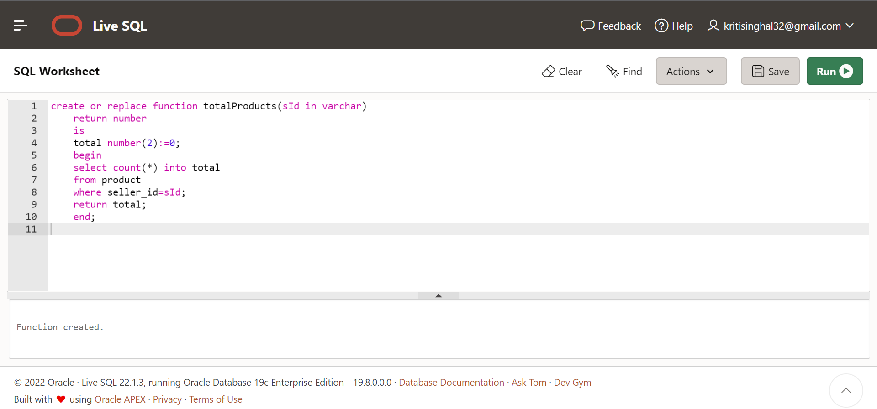

**Function execution:**

declare

c number(2);

begin

c:=totalProducts('1ABQ36');

dbms_output.put_line('Total products is : '|| c);

end;

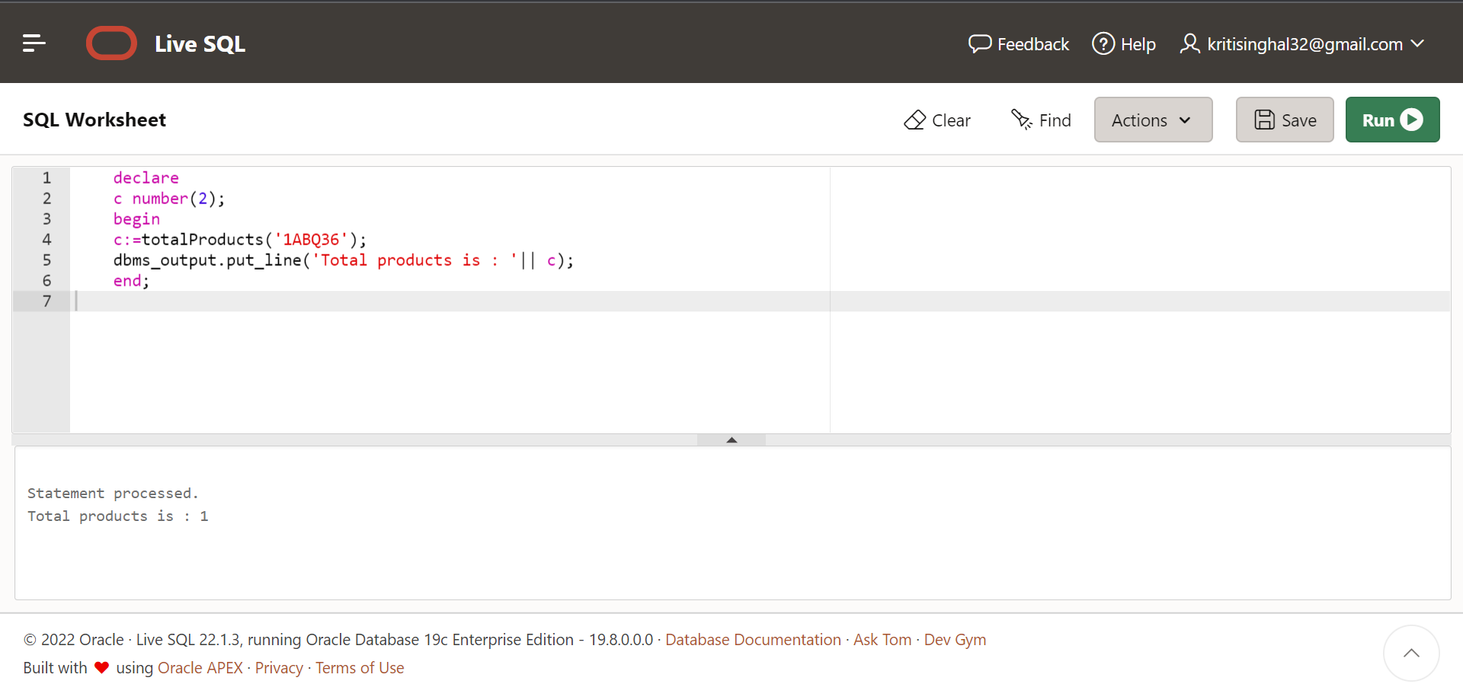

1. **Procedure which returns the total quantity of product with the given ID (Procedure with exception handling)**

create or replace procedure prod_details(p_id in varchar)

is

quan number(2);

begin

select quantity into quan from product where product_id=p_id;

exception

when no_data_found then

dbms_output.put_line('Sorry no such product exist !!');

end;

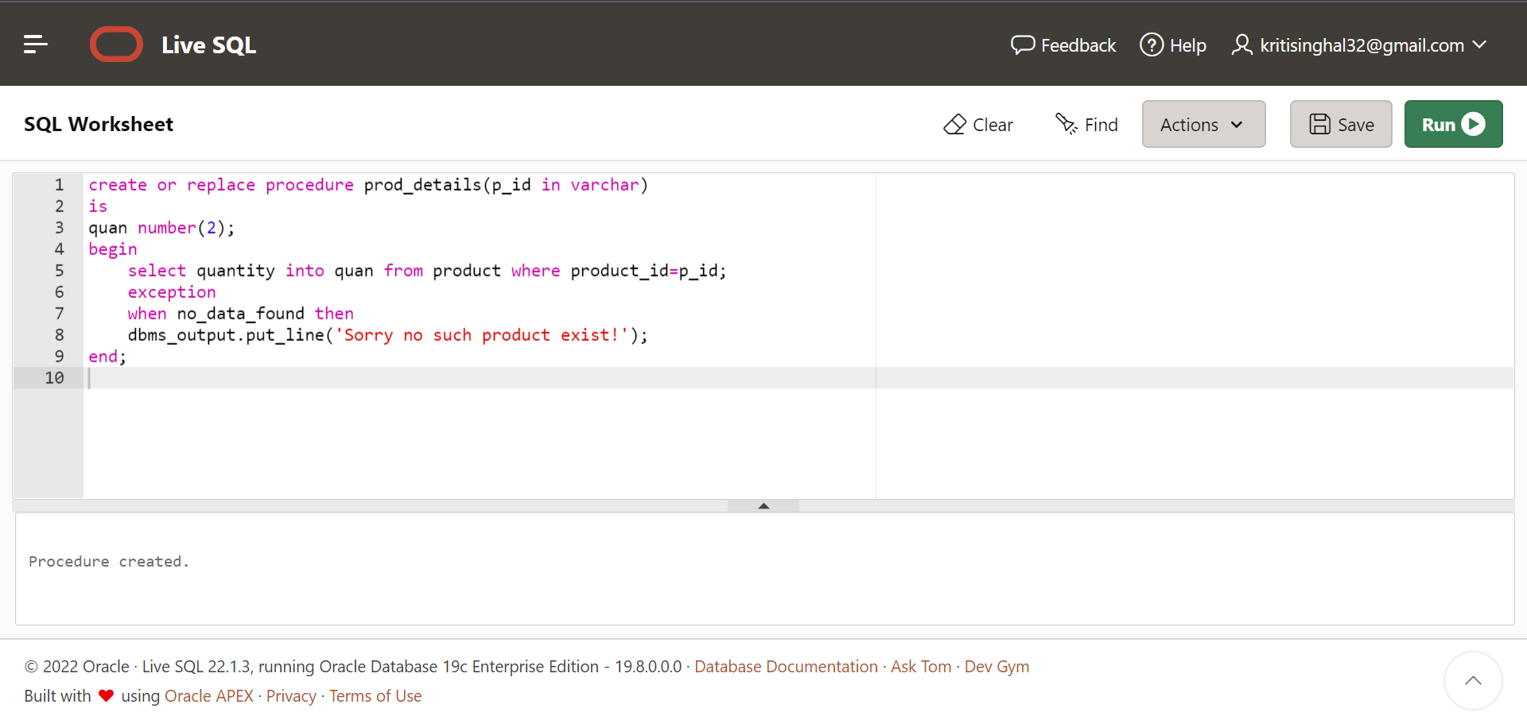

1. **Procedure to delete seller info based on sellerid**

create or replace procedure deleteseller(sellerid varchar)as

begin

delete from Seller where Seller_id=sellerid;

end;

declare

s varchar(6);

begin

s:='17KLP7';

deleteseller(s);

end;

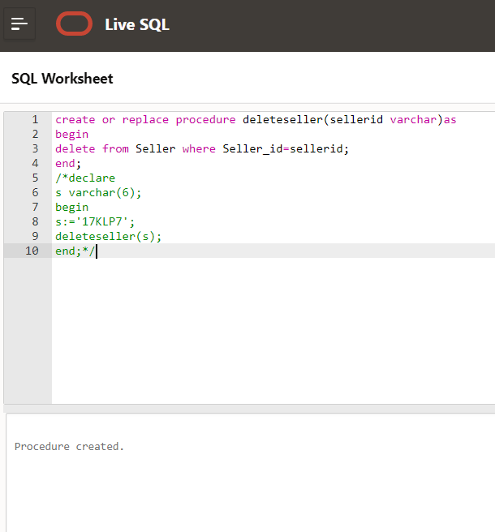

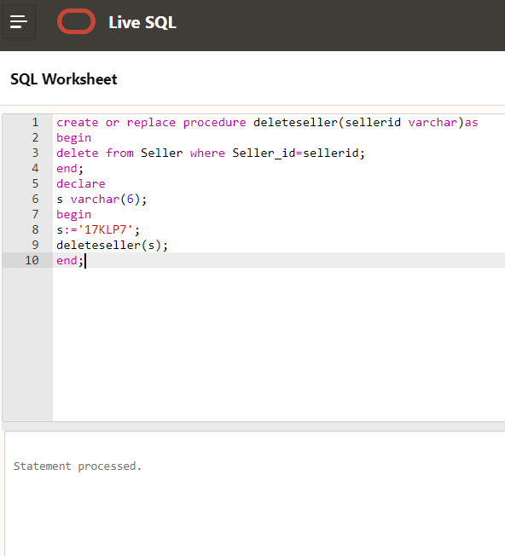

1. **Triggers:**

**Trigger that will execute before inserting new customer to database and inserting a new cartId to the cart_items table (Function to count number of cart items)**

create or replace function numCartId(cd in varchar)

return number

is

total number(2):=0;

begin

select count(*) into total

from cart_item

where cart_id=cd;

return total;

end;

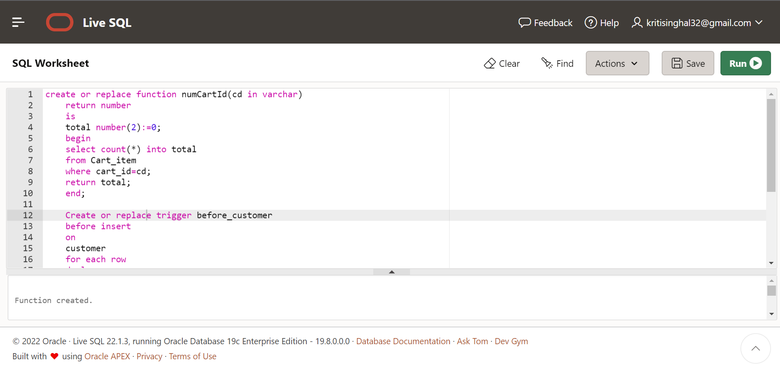

Create or replace trigger before_customer

before insert

on

customer

for each row

declare

c varchar(10);

n number(2);

begin

c:= :new.cart_id;

n:=numCartId(c);

if n>0 then

dbms_output.put_line('Sorry');

end if;

insert into cart values(c);

end;

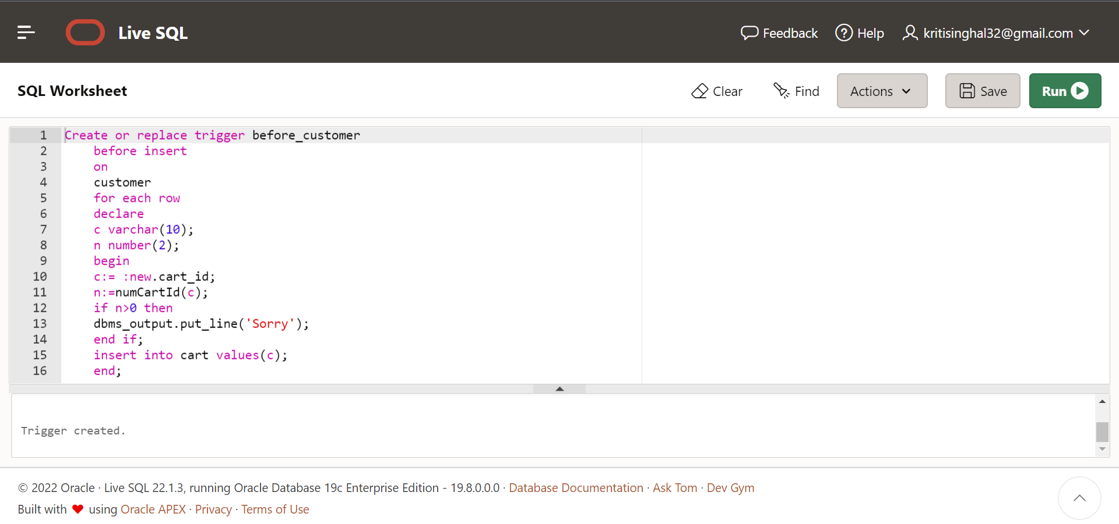

1. **Trigger to update the total amount of user everytime he adds something to payment table**

create or replace function total_cost(cId in varchar)

return number

is

total number(2):=0;

begin

select sum(cost_p) into total from product,cart_item where product.product_id=cart_item.product_id and cart_id=cId;

return total;

end;

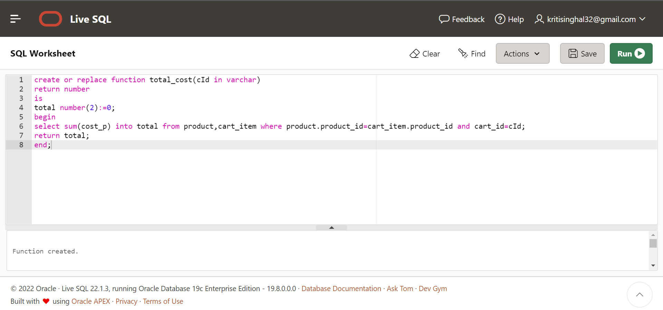

create or replace trigger before_pay_up

before insert

on

payment

for each row

declare

total number(3);

begin

total :=total_cost(:new.custid);

insert into payment values(:new.payment_id,total,:new.payment_date,:new.custid);

end;

